

**Rethinking the connections between care and climate: a nexus approach.**

This document was coordinated and supervised by Francisco Cos-Montiel and María Noel Estrada, staff members of the United Nations Research Institute for Social Development (UNRISD). Julio Rosado, María Noel Estrada, Fabio Vélez, Francisco Cos-Montiel and Anuar Said were responsible for the preparation of this document. We would like to thank Agnieszka Raczynska (AVINA), Ana Moreno (GAC), Carolina Robino (IDRC), María Gracia Aguilar (AVINA), Patricia Carmona (AVINA), Rebecca Boyce (Oxfam), Yara Tarabulsi (GAC) and all those who participated in the face-to-face and online meetings held during the elaboration process of this document for their valuable collaboration and contributions (in alphabetical order). This document has also benefited from formal and informal conversations with Ana Güezmes (ECLAC), Karina Batthyany (CLACSO), Marta Ferreyra (INMUJERES Mexico), Marta Lamas (UNAM), Nadine Gasman (INMUJERES Mexico), Naila Kabeer (LSE), Rania Antonopulos (Levy Institute) and Silvia Giorgule (COLMEX).

The opinions expressed in this document, which has not been subjected to editorial review, are the sole responsibility of the authors and may not coincide with those of the Organizations and Institutions.

Content

Introduction 5

Why work at the intersection of climate and care? 6

Is it necessary to rethink the concept of care to highlight the care-climate nexus? Just transitions with a gender perspective 12

Do new concepts lead to a revision of strategies? 19

Beyond the 5 R's: Exploring new dimensions of integration. 21

From the care diamond to the prisms of the care-climate nexus 25

Revisiting care-climate issues. A consequence of the nexus approach 33

Environmental care 37

Just transition and economic empowerment 37

Financing 39

Community care 40

Redistribution and cultural change 41

Identifying critical intersections between the impacts of the care and climate crises 42

Conclusions 47

Research opportunities and challenges 48

Bibliography 54

Table of Boxes

**Box 1 - Principles of a Just Transition with a Gender Perspective (WEDO)** 14

**Box 2 - The 5Rs framework** 22

**Box 3 - The prism of care. An exercise in conceptualizing and integrating sectoral, intersectional and interconnected policies.** 33

**Box 4 - From the isolated approach to the care-climate nexus approach, a first roadmap.** 34

**Box 5 - Summary of some research gaps in care-climate linkages and possible approaches to address them** 53

Table of Figures

**Figure 1 - Beyond the 5 R's: Exploring new dimensions of integration.** 23

**Figure 2 - The Care Diamond .** 26

**Figure 3 - The new dimensions of the care diamond - Dimension 1: Home and family** 27

**Figure 4 - The new dimensions of the care diamond - Dimension 2: Status** 27

**Figure 5 - The new dimensions of the care diamond - Dimension 3: Marketplace** 28

**Figure 6 - The new dimensions of the care diamond - Dimension 4: Not-for-profit** 28

**Figure 7 - The new dimensions of the care diamond - Understanding the prisms of care** 29

**Figure 8 - Care-climate nexus approach: from the care diamonds to the care prism** 31

# Introduction

The climate change crisis has developed within a cascading series of crises (ECLAC, 2024), including the care crisis. Specifically, the care crisis refers to the situation in which the demand for care exceeds the capacity of individuals and systems to adequately provide it (UN Women, 2020; ILO, 2018). This crisis has been exacerbated by a persistent cycle of debt, austerity policies and cuts in public services, leaving many people without access to needed care. This situation imposes significant costs on people who require and receive care, but also on caregivers, particularly women and girls, who are primarily responsible for these tasks (Turquet et al., 2023).[1]

These cascading effects constitute an epochal crisis (Fraser, 2021) that encompasses multiple dimensions: economic, social, political, social justice, democratic representation and ecological. These phenomena have pervasive and mutually reinforcing effects, accelerate the existential threat of climate change and weaken the political conditions necessary to address it (Turquet et al., 2023).

The intersections between climate change and care work are not merely coincidental, but are intrinsically linked to issues of gender equality, sustainability, and economic, environmental and social justice. These linkages, while highlighting vulnerabilities, also open up opportunities for innovative policy interventions that can simultaneously address climate change and improve the visibility and valuation of both paid and unpaid care work.

A nexus approach seeks to expand the boundaries of traditional climate, care, gender, and development policy frameworks to incorporate holistic and integrative approaches. This approach recognizes the dual need to address the impacts of climate change and to restructure the social organization of care. In doing so, it aims to catalyze a transformation towards policies that not only respond to climate change, but also contribute to building strong care systems that support well-being, prosperity and care for the planet and those of us who live on it.

# Why work at the intersection of climate and care?

To highlight existing inequalities

In recent years, the intersection between climate and gender has gained increased attention, driven by the development of gender and climate change initiatives under the Conventions of the Parties since the early 2000s. An important milestone in this process was the Lima Work Program on Gender in 2014, which, through [Decision 18/CP.20](http://unfccc.int/resource/docs/2014/cop20/spa/10a03s.pdf#page=41) promoted the inclusion of a gender perspective in climate policies. This increased visibility has led to the development of systematic research on the topic. The climate-gender intersection refers to how climate change policies and effects impact men and women differentially due to pre-existing gender inequalities. This has been the subject of more extensive research due to growing awareness of the need for equitable approaches to climate action.

On the other hand, the intersection between climate and caregiving has been less explored. This intersection addresses how climate change affects and is affected by care responsibilities. This link, little analyzed - with the exception of some specific case studies approached from the climate-care perspective - (MacGregor et al., 2022; UN Women, 2023a), is crucial to understand the impacts of climate change on society.

Given their interdependence for development, there is an urgent need to address the linkages between care and climate change. Until recently, the climate change and care agendas seemed to be limited to areas of overlap and coincidence, but now they are beginning to be thought of as inseparable and integrated, even encompassing previously ignored areas. The linkage of climate change with care - if the goal is a just transition - is not an occurrence or coincidence, but is intertwined with issues of gender equality, sustainability and economic, environmental and social justice, and the interrelationships between all of these.

**Box 1. Lima Work Program on** Gender

Within the framework of the Twentieth Conference of the Parties (COP 20) and the Tenth Meeting of the Parties to the Kyoto Protocol (CMP-10), held in Lima in December 2014, the development of the Lima Work Program on Gender was announced. This program commits the parties to the United Nations Framework Convention on Climate Change (UNFCCC) to advance the implementation of climate mandates and policies that incorporate gender considerations in all areas of negotiation. This program aims to strengthen gender mainstreaming in climate action. This includes promoting the full and equal participation of women at all levels of climate change decision-making processes and developing gender-sensitive policies.

<https://unfccc.int/es>

The relationships between climate change and care could represent a compelling framework for understanding current socioeconomic and environmental dynamics. As global attention increasingly focuses on the impacts of climate change, turning to the production and reproduction of care-activities often unpaid and unrecognized in the sustainability of life-not only highlights vulnerabilities, but also opens avenues for innovative policy interventions that can simultaneously address climate change and care.

Growing evidence on the intersection of gender and climate change reveals negative impacts on economic and social outcomes that are exacerbated by underlying gender inequalities, and by the lack of integration of gender perspectives into environmental policies (IPPC, 2022). The extractive economic system, focused on short-term growth and profits, intensifies structural inequalities (including gender inequalities), increasing the vulnerability of certain populations to the impacts of climate change (Coffey et al., 2020, UNDP 2020). For example, due to climate change the amount of food produced will be reduced and disease will increase, resulting in greater burdens and time demands on women and girls, as it is these population groups that are traditionally expected to provide the labor needed to cope (Coffey et al., 2020:16).

These structural inequalities are not limited to determining how the impacts of climate change are distributed, but also condition people's capacity to respond to them, in addition to perpetuating a cycle of vulnerability and inequality in the face of environmental challenges (Coffey et al., 2020; Gamble et al., 2016).

At the level of population groups, the impacts of climate change also disproportionately affect the most vulnerable, especially women and girls, particularly those in the global south, who bear the greatest responsibility associated with unpaid care work. Emerging evidence suggests that climate change and environmental degradation increase and intensify care work due, in part, to the increased frequency and intensity of extreme weather events and reduced availability of natural and material resources (ESCAP, 2023).[2] Displacement and the health impacts of climate change and environmental degradation also increase unpaid care work.

Caregiving responsibilities exacerbate the constraints women face in participating in decision-making on climate action, and limit their opportunities to work in green jobs fostered by the low-carbon transition. Programs, policies, and cultural norms that discriminate on the basis of gender mean that women often have less access to income and finance, time, employment, and productive resources. This means that when weather patterns change, disrupting infrastructure and public services, women are less able to adapt their livelihoods, recover and rebuild (Turquet, et. al 2023).

This is despite the fact that women are at the forefront of climate action, given that many of the activities they are assigned include environmental and biodiversity care tasks.[3] In this way, women's work not only protects their communities and the environment, but also strengthens climate change mitigation and adaptation strategies (UN Women, 2022). However, this evidence should be taken with caution, as it could lead to an instrumentalization of women in climate change mitigation and adaptation strategies and may add more responsibilities to their already busy schedules. As with caregiving, the conclusion is that climate change mitigation and adaptation strategies should be shared equally by women and men.

Natural disasters accelerated by climate change not only increase the demand for care in terms of illness and disability, but also create new challenges that undermine the availability of family caregivers to provide care and their ability to access care support services (Floro et.al, 2023; Turquet, et. al 2023).

An example of this is the disruption, and even destruction, of essential care infrastructure, including health facilities, day care centers and schools. Damage to these critical services leaves communities with severely reduced access to needed care, exacerbating the vulnerability of already affected populations. In the immediate aftermath of a disaster, there is a significant increase in care needs, but the capacity to meet these needs is generally drastically diminished.

Caregivers bear the brunt of these multiple challenges. They must simultaneously rebuild their homes, provide for their families, and ensure the survival of dependents under increasingly adverse conditions. Community spirit and mutual aid within communities can offer some relief, but overall resilience and recovery efforts depend heavily on external support and policy interventions (UN Women, 2020).

In addition, the loss of life among caregivers during climate disasters further exacerbates the crisis: as caregivers struggle to secure basic necessities, such as food and clean water, the health of care recipients deteriorates due to the inaccessibility of health services.

Climate change also exacerbates pre-existing vulnerabilities within paid care systems - which themselves face conditions of structural overload and underfunding. Paid caregivers, also mostly women, are exposed to increasingly precarious working conditions, especially in the context of extreme weather events. These events increase the demand for this type of care and aggravate the shortage of human and material resources in a sector that has historically been undervalued and feminized. In addition, the infrastructure of care centers - often inadequate to cope with the new climatic realities - reflects the lack of political and financial prioritization towards care (Mejier et al, 2020).

To develop and apply approaches that meet current circumstances

The increasing inability of societies to meet care needs due to the interaction of climate change and various socioeconomic and structural factors has immediate and long-lasting effects on well-being, including the depletion of tangible capabilities and loss of human life (Floro et.al, 2023). Poverty, gender inequality, poor infrastructure, limited access to basic services, political instability, economic inequality, economic dependence on natural resources, and limited mobility are factors that interact with climate change, exacerbating its impact (UN Women, 2020).

Policy makers have yet to consider the bi-directional effects of economic activities and the interactions between production, consumption and ecosystem processes in decision-making processes and policy analysis (Daly, 2014; Floro et al., 2023). In the pursuit of economic growth, governments, international agencies and the private sector, especially extractive and oil and gas industries, have implemented and promoted development policies that mostly do not consider the negative impacts on the care economy and the environment (Floro et al., 2023).

Feminist climate justice, based on the recognition of these interconnections, advocates for transforming economic and social policies to prioritize equity and sustainability, promoting the redistribution of resources and the meaningful representation of women and marginalized groups in climate-related decision-making. This comprehensive approach seeks to mitigate vulnerability and strengthen the resilience of affected communities, ensuring that responses to climate change are inclusive and equitable (Njuki et al., 2022; Bryan et al., 2023; Turquet et al., 2023; ILO, 2022; Floro et al., 2023).

The care economy is presented as an alternative to build more resilient and just economies, breaking with the extractivist model that has generated the current climate crisis (Coffey et al., 2020; MacGregor et al., 2023). This approach implies a paradigm shift: moving from a system that prioritizes "profit" to one that values "care" as the central axis, both for people and for the environment on which we depend.

Economic theory would suggest that internalizing the externalities of care work and the effects of climate change in economic models could help design policies that promote socioeconomic development (Krogstrup, S., & Oman, W., 2019). Integrating climate and care policies can generate multiple economic and social benefits. For example, investing in climate-resilient care infrastructure not only reduces the burden of unpaid care on women, but also creates green jobs and fosters sustainable economic development.

The climate-care nexus also challenges economic models that segregate productive and reproductive work, calling for a re-evaluation that recognizes the substantial contribution of care work to economic systems and environmental management. This reassessment is crucial for formulating more inclusive and sustainable policies. In this context, funding policies and subsidies could be targeted to support women in green sectors, facilitating a just and equitable transition. By recognizing the value of care work and promoting women's access to jobs in the green economy, both gender equity and environmental sustainability are strengthened.

# Is necessary to rethink the concept of care to highlight the care-climate nexus? Just transitions with a gender perspective

Reproductive work, which includes domestic and care work, mostly performed by women and in an unpaid manner, is part of the broader agenda of socioeconomic development and gender equality. Domestic and care work, indispensable for the reproduction of life, are conditioned by the sexual division of labor, which becomes a crucial factor restricting the capabilities and rights of women and girls (ILO, 2018). Therefore, care must be seen as a cross-cutting issue that crosses and integrates with several dimensions, just like climate change.

Well, by recognizing that the care crisis is aggravated by the climate crisis and environmental degradation, and that the intersection of both tends to have a greater impact on the global south, on women and girls with low resources, and in rural or island contexts (MacGregor et al., 2022), the adoption and enhancement of this specific intersection can contribute to making visible in a significant way what might otherwise be in danger of being hidden or relegated in a global agenda, usually biased by hegemonic interests. Under these considerations, in 2012 the concept of just transition was incorporated into the outcomes of the United Nations Conference on Environment and Development Rio+20, and in 2015, it was recognized in the preamble of the Paris Agreement (Lee and Baumgartner, 2022).

The transition to a low-carbon economy is a global imperative, but for this process to be truly equitable and effective, it must be framed within the principles of justice. Originally linked to the protection of workers' rights in sectors affected by decarbonization, this concept has evolved into a platform for addressing social justice in a comprehensive manner, incorporating issues of gender equality, social protection and resource redistribution. Broadly speaking, a just transition refers to the process, principles and practice to ensure that the transition to a low-carbon economy is socially just (Cerise et.al, 2024).

The concept of a just transition has gained popularity among groups and institutions that recognize the ways in which such a transition could articulate their own priorities and concerns for environmental, energy and social justice (Newell and Mulvaney, 2013). Just transition discussions have primarily focused on ensuring that rapid deployment of low-carbon technologies and systemic shifts toward decarbonization are inclusive and integrated with development priorities at all levels (Lee and Baumgartner, 2022).

The ILO (2022:3) states that a just transition aims to green the economy in the fairest and most inclusive way possible for all stakeholders, including women, creating decent work opportunities and leaving no one behind. However, there is no universally accepted definition, although the concept is widely used to advocate for social justice and equity in climate action (Lee and Baumgartner, 2022). While these definitions include concepts such as equity, none specifically address care. [4]

A transition to low-emission economies that are resilient to a changing climate requires that gender-specific risks and vulnerabilities be recognized and addressed; and that resources be redistributed fairly so that such transitions are equitable and women and all of society can benefit from future opportunities (Turquet et. al, 2023). Without explicit attention to and prioritization of gender justice in transition, adaptation and mitigation policies, solutions to climate change could almost certainly reinforce structural gender inequalities (Cerise et. al, 2024).

A just gender transition requires a transformed economy that focuses on people's well-being, values care for people and the environment (Cerise et.al, 2024). It requires, yes, climate justice[5] , but feminist climate justice . [6]

La justicia climática feminista aporta una perspectiva transformadora a las transiciones justas y a la justica climática, al mostrar cómo los percusores y potenciadores del deterioro climático son también los impulsores estructurales de otras desigualdades incluyendo las de género. La visión de la justicia climática feminista es la de un mundo en el que todas y todos puedan disfrutar de los derechos humanos y prosperar en un mundo saludable y sostenible y, para ello, es necesario transformar las políticas económicas, sociales y ambientales (Turquet et. al, 2023).

**Box 1 - Principles of a Just Transition with a Gender Perspective (WEDO)**

The Women's Environment and Development Organization (WEDO) stresses the need for governments, key actors and allies to move forward in implementing a Just Transition that puts women's rights at the center and dismantles systems of oppression. The fundamental principles that should guide this transition include:

1. **Redistribution of power**: Shift power from hegemonic industries to local communities, with a focus on women, girls and gender-diverse people, prioritizing locally-led solutions.
2. **Redistributive justice**: Ensure an equitable distribution of resources to strengthen the resilience of communities by investing in essential public services such as health, education and social protection.
3. **Decent jobs**: Promote workforce diversification, wage equity and the strengthening of labor rights, ensuring safe working conditions and access to care services.
4. **Elimination of gender stereotypes**: Facilitate women's access to green jobs, overcoming gender barriers through training and retraining in low-carbon economy sectors.
5. **Valuing care work**: Recognizing, redistributing and remunerating care work, guaranteeing policies that support both the productive participation of women and the recognition of their care work.

(Based on the WEDO document, 2023 Gender Just Transition: A Path to System Change).

In this sense, the care agenda stands as a central axis of this discussion. Initiatives such as the WEDO report (2023) underline the importance of a Just Transition with a gender perspective, which recognizes the contribution of women and promotes concrete measures to reduce the gender gap in sectors such as energy and green jobs. Only by mainstreaming the care agenda will it be possible to ensure comprehensive climate justice that promotes not only environmental sustainability, but also equitable social and economic transformation (See **Box 1**) (WEDO, 2023).

In order to trace the climate-care intersections, it is then necessary to signify and define the aspects that comprise care. Care is a universal good and value that in analytical terms requires considering the multiplicity of interconnected facets of acting/caring in which this good and value is involved (Araujo, 2024).

Care is a concept under construction with multiple definitions that vary according to the context in which it is developed (Batthyány, 2021; Fraser, 2016; Anderson, 2007). In general, the term alludes to a multitude of activities fundamental to the biological, social and cultural reproduction of any human group (Soto et al., 2022), involving material, economic and cultural (symbolic and subjective/psychological) dimensions (Zibecchi, 2014; Batthyány 2013; Oliveira and Faria, 2018; Pino et al., 2017; Mascheroni, 2021). Care is not by definition of a paid or unpaid nature, but rather a product of political choices, shared cultural valuations and gender systems (Batthyány, 2021; CLACSO/ONUMujeres, 2022).

The current social organization of domestic and care work fundamentally assigns to women the responsibility of carrying out all those activities that allow people to stay alive, develop emotionally and physically, feed themselves, be healthy, educate themselves and live in a habitat conducive to their development and well-being, without these tasks being socially or economically recognized. This assignment, almost exclusively for women, represents great economic, social, physical and emotional costs for them, and has profound effects on the persistence of inequality between women and men, as well as on the guarantee of their rights (Ferreyra, 2021).

The first specific research on care emerged in Europe and the United States in the 1980s, based on the reflection on the new roles acquired by women in the labor market and a greater displacement of care outside the family sphere (Carraquer, 2013, CLACSO/ONUMujeres, 2022). Care began to be addressed as one more among the different types of unpaid work. The emphasis in the study of domestic work was on making visible the tasks that women performed in the home in an unpaid manner -but which contributed to social welfare-, and care occupied a secondary place in the analyses (Batthyány, 2024).

The concept of care work has been defined and approached in different ways in the literature and in practice. For example, the term care is used rather than "care work" because it conveys broader meanings (Esquivel, 2013), and it is common to distinguish between paid and unpaid care work, even when it is recognized that all forms of care work are considered fundamental to the human economy (Coffey et al. 2020).

Care work, mention MacGregor et. al (2022), is widely used together and interchangeably with concepts such as care and care services (Razavi 2007), domestic work (Molyneux, 1979), sustaining services (Perkins 2007) and social reproduction (Bakker 2007; Bhattacharya 2017). Other authors have emphasized the distinction between direct (hands-on) care work and indirect care work (provision of necessary goods and services) for individuals (Folbre, 2018), even though the boundaries between paid and unpaid care, and direct and indirect care, are often difficult to establish (MacGregor et. al, 2022).

In Latin America, the conceptualization of care has had its own particularities (CLACSO/ONUMujeres, 2022). Its study began in the 1990s, starting with the debates on unpaid female work (Batthyány, 2021; Guizardi et al., 2022). Care, as a concept of analysis, presented similarities with domestic work given its association with female skills and its invisibility, but differentiated by the relationships of consanguinity or closeness between the person receiving care and the caregiver (Carrasco et al., 2011). In Africa, this conceptualization has evolved in response to social and economic dynamics unique to that region. Thus, unlike in Europe and Latin America, in Sub-Saharan Africa the debate has been marked by factors such as widespread poverty, weak social protection systems, and the impact of HIV/AIDS (Folbre, 2014; UNDP, 2022).

The perspective of care as a component of well-being has focused on care as a relevant category for the analysis of welfare regimes (CLACSO/ONUMujeres, 2022). The approach to care as a component of welfare has its origin in the criticisms applied from feminism to the typologies of welfare regimes introduced by Esping-Andersen (1990) with the distribution of social responsibilities between the State, the market, the family and the voluntary sector (Batthyány, 2024).

In the 2000s, it is not possible to understand the form and nature of a current welfare regime without addressing care (Daly and Lewis, 2000). This implies going beyond the analysis of care from the domestic sphere and integrating other public and private institutions that provide care (CLACSO/ONUMujeres, 2022).

In Latin America, for example, welfare regimes were based on the principle of solidarity between people with different income levels, between the healthy and the sick population, and on the relationship between the generation of assets and liabilities (Mesa-Lago, 2005). This principle of solidarity varied between countries. Differences were reflected primarily in aspects such as stratification, coverage, contribution ceilings, and the allocation of health resources (Mesa-Lago, 2005).

Traditionally, the informal sector was not part of the region's protection systems, and although there are cases that did include incentives for self-employed workers, these were not enough to reverse the regressive impact on income distribution, disproportionately benefiting those who already had greater resources (Mesa-Lago, 2005). The incorporation of informality into the sphere of welfare provision is not a minor aspect, given the levels of informality in the Latin American region (Marcel and Rivera, 2008).

In this sense, Martínez's (2007) classification emphasizes the role of the State and the degree of familiarization of risk management. This is observed by the author through 4 dimensions: degree of commodification of the labor force, degree of decommodification, degree of familiarization, and results in living conditions. Familiarization refers to the autonomy of welfare vis-à-vis the availability of unpaid female labor (Martinez, 2007). This variable is one of Martínez's contributions to the classification of welfare regimes, as it is an attempt to consider female work and unwaged work (which are variables not fully visible in other typologies) (Ubasart- González and Minteguiaga, 2017).

Another vein of analysis comes from the economic analysis of the care sphere. The concept of care economy is a term commonly used by feminist economists to situate unpaid care work in a system composed of a mix of different actors, relationships and spaces that together organize and ensure social reproduction (Folbre 2014; Elson, 2017). The care economy refers to a space of production and circulation of goods, services, activities, relationships and values linked to the reproduction and sustainability of life (Soto et al., 2022). Again, the distinction between care economy, domestic work and reproduction of life is not free of tensions.

The care economy approach focuses on the components of care that produce or contribute to producing economic value (CLACSO/ONUMujeres, 2022). The care economy analyzes the systemic role of care work for economic dynamics, without neglecting the consequences that the social organization of care has for the lives of people, particularly women (Rodríguez, 2015; CLACSO/ONUMujeres, 2022). That is, the care economy denotes the fact that care work, whether paid or unpaid, produces value; hence, all forms of care activities are considered productive, even if most of these activities are invisible to conventional economic and production measures and indicators (Floro et. al., 2023).

Taking all of the above into consideration, the definition of care work used in this document is that of the Global Alliance for Care, based on the definitions of ECLAC and UN Women. According to this definition, "...care work consists of all those activities performed to ensure the daily well-being and development of people from various perspectives: physical, economic, moral and emotional. As such, it ranges from the provision of essential elements for human life, such as food, shelter, sanitation, cleanliness, health, companionship and a healthy environment to the support and transmission of knowledge, social values and practices, through processes related to parenting and other community dynamics. Care work consists of two types of activities: direct, personal and relational care activities...; and indirect care activities...".[7]

This comprehensive definition of care, which considers intersectionality and gender inequalities, is fundamental for developing policies and programs that adequately recognize and value care work in all its forms. By recognizing the breadth and complexity of care, it is necessary to move towards a more equitable, just, sustainable (climate change mitigation) and resilient (climate change adaptation) society; where care work is made visible, valued and fairly compensated, thus contributing to long-term social, economic and environmental sustainability.

# Do new concepts lead to a revision of strategies?

This forces us not only to reconsider the notion of care as we have traditionally understood it, but also to reevaluate categories of feminist and development economics. At the beginning of the 21st century, for example, Benería (2006) urged us to rethink the classic dichotomy between productive and reproductive work -especially with regard to the categories of paid and unpaid work and the dichotomy of the public and private spheres-. This reflection was based on the recognition that the classic correlation - that reproductive work is unpaid - needed to be qualified. Today, in turn, experiences sometimes ignored in research agendas and international cooperation, force us to contemplate care beyond the assumptions of the Global North and urban contexts (MacGregor et al., 2022).

This includes the recognition of environmental care, the interconnection between productive and reproductive work, and the community and collaborative dimension of care. Thus, it is recognized that care is not only limited to the domestic sphere, but also encompasses the management of natural resources and the sustainability of ecosystems, which implies a profound revision of previous conceptualizations, explicitly incorporating environmental, community and social justice dimensions into the spheres of care.

By virtue of this, this reconsideration has had a direct translation when it comes to naming and redefining care. Thus, we have moved from anthropocentric, person-centered care to care that contemplates and incorporates care and the sustainability of life in general. Proof of this is the fact that it is increasingly common to find in reports and articles -from UN agencies, civil society and academia- expressions such as "care for people and the planet" (UN Women, ILO, etc.) or even definitions of "care societies" that include "...self-care, care for people, for those who care and for the planet..." (ECLAC, 2022).

As we have seen so far, the concept of care has evolved significantly, from being a secondary aspect in the development agenda[8] to becoming a fundamental element due to its role in the reproduction of life and the sexual division of labor, and in development. Thus, a comprehensive definition of care, which considers intersectionality and gender inequalities, must be broadened to include not only the care of people, but also the physical, emotional and environmental dimensions of well-being, recognizing both paid and unpaid work. This is essential for developing policies and programs that adequately value and compensate care work in all its forms. In this way, a broader understanding of care is achieved, and this, consequently, must be accompanied by novel and transformative conceptual developments and political endeavors (political action and public policy).

Integrating these responses requires not only interagency collaboration, but also the formulation of policies and strategies that recognize and act on the interdependencies between the different affected spheres. Such approaches promote greater resilience and sustainability in responses to crises, including the climate change crisis. For example, the UN emphasizes the importance of integrated and coordinated approaches in its 2030 Agenda for Sustainable Development, which stresses the need to work in partnerships to achieve the Sustainable Development Goals (SDGs) and recognizes that the interconnected nature of the SDGs requires multidimensional and coordinated responses (UN, 2015).

In addition, the World Health Organization (WHO) has emphasized that "addressing the social determinants of health requires coordinated and multisectoral actions" (WHO, 2016). This is particularly relevant in the context of climate and care crises, where actions in one area can have significant effects on others. For example, improving access to care services can have a positive impact on people's health and well-being, which in turn can strengthen community resilience to climate disasters.

## Beyond the 5 R's: Exploring new dimensions of integration.

In recent years, social policies have incorporated into their analyses the effects and consequences of the feminization of care work in maintaining and widening inequality gaps between women and men (MacGregor, et.al, 2022). Some of the approaches used to address this connection, however, have been conservative in the sense that they have sought to make women's care work easier to do or a source of empowerment. Others have been transformative, in the sense that they seek to modify and transform the patriarchal norms that underpin the undervaluing of care and women's disproportionate responsibility for it, with gender justice as one of the goals (Fraser, 1997 and 2013).

One of the most concurred frameworks in the literature and public policies to analyze and transform care work is that of the Rs (commonly 3 or 5 Rs), developed from Elson's proposal to analyze unpaid work presented at a UNDP seminar in 2009 (Elson, 2017). It was taken up by the ILO, defining this framework as a public policy approach based on human rights and with a gender perspective (Adatti et al.2018).

The framework creates a virtuous circle that mitigates care-related inequalities, addresses barriers that prevent women from accessing paid work, and improves conditions for all care workers and, by extension, the quality of care (Adatti et al.2018). To transform inequalities in care this framework emphasizes recognition, reduction, and redistribution (the three Rs posited by Elson) of care work; as well as representation and reward (these two Rs added by the ILO) (See **Box 2**).

|  |
| --- |
| **Box 2 - The 5Rs framework**  **Recognize**   * Recognize women's care work throughout their lives. * Incorporate measures of paid and unpaid care work into national statistics and economic measures such as GDP. * Measure the use of time and unpaid care work and its distribution within families and communities. * Monitoring of care in public policies and investments.   **Reduce**   * Increase access to care infrastructures and technologies that save time and improve working conditions.   **Redistribute**   * Invest in quality, affordable and accessible care services. * Ensure gender-sensitive social protection systems with care at the center. * Implement maternity, paternity and parental leave policies with a gender perspective. * Implement home-friendly workplace policies and agreements. * Changing social norms about caregiving. * Involve men and fathers in caregiving. * Develop advocacy and training tools relevant to care.   **Reward**   * Guarantee decent work for all care workers, including those in the informal economy. * Extend social protection to informal workers. * Apply the principle of equal pay for work of equal value.   **Represent**   * Formalize care and domestic work. * Promotion of freedom of association, social dialogue and collective bargaining for care workers. * Guarantee equal opportunities and treatment for migrant care workers.   Taken from "The Climate-Care Nexus: Addressing the Linkages Between Climate Change and Women's and Girls' Unpaid Care, Domestic and Communal Work., Economic Empowerment Section-UNWomen, 2023. |

The global discourse on care work shifted from a 3Rs framework to a 5Rs framework, whereby recognition, reduction and redistribution of unpaid care work are complemented by rewarding and representing paid care work. However, the 5Rs framework addresses care work without considering the synergies, tensions and trade-offs between the different R's for sustainable development or for addressing the climate emergency (MacGregor et.al, 2022). However, there are possible pathways where climate actions can simultaneously contribute to gender transformative change (a win-win) but more evidence-based interdisciplinary analyses of these possible pathways are needed (MacGregor et.al, 2022).

Considering the above, it is striking that the 5Rs of care compass (recognize, reduce, redistribute, reward and represent) -which has received broad consensus and is still largely used to think politically about the climate-care intersection- has not been revamped or definitively expanded with a new R that specifically addresses the dimension of environmental care (MacGregor et al., 2022), which opens a research possibility to continue advancing and reinforcing this framework.

Recently, suggestions have been made to evolve this framework into one of 7Rs, incorporating the resilience of care systems to shocks such as climate change and environmental degradation, and the resources needed to support and fund policy implementation (See **Figure 1**) (Economic Empowerment Section-UNWomen, 2023).

**Figure 1 - Beyond the 5 R's: Exploring new dimensions of integration.**

Own elaboration based on "The Climate-Care Nexus: Addressing the Linkages Between Climate Change and Women's and Girls' Unpaid Care, Domestic and Communal Work, Economic Empowerment Section-UNWomen, 2023.

Moreover, Turquet et al. (2023) have proposed, to the 5Rs framework, the additional R of "Reparation" that would focus on recognizing historical injustices related to accumulated emissions, as well as implementing adequate global climate finance (including debt cancellation) and considering mechanisms to address gender-related socioeconomic losses and damages. Reparations would involve not only compensating for material losses, but also recognizing the long-standing impacts that historical injustices have had on vulnerable communities, and promoting mechanisms for accountability and global redistribution of resources (Turquet et.al., 2023).

The Rs framework is one of the approaches adopted by a large number of feminist academics and institutions, and given its characteristics it can be useful for discussing climate change and care interventions and using it to identify solutions and design policies that improve the distribution and conditions of care in low-income rural contexts (MacGregor, et.al, 2022).

This mechanism - by highlighting the interdependence and intersectionality of aspects such as the recognition of diverse identities, experiences and forms of knowledge, the redistribution of resources, and the representation of women and other excluded population groups in decision-making related to climate change - is consistent with the feminist climate justice approach. The proposed addition of the above-mentioned dimensions of "Resilience" and "Resources" (7Rs framework), and the incorporation of the R for "Reparations" (8Rs framework) could further strengthen and make explicit the framework's links to feminist climate justice, particularly in the areas of public policy and political action.

However, the integration of new Rs - such as resources to finance policy implementation, resilience to crises and redress for historical injustices - raises the need to study carefully how these new dimensions interact with the original Rs, giving rise to the R of *Rethink*, in a sense of encouraging research to address the emerging dimensions of care-climate change or care-technology and highlighting their importance in finding better ways to address the current crises in these areas. The incorporation of this R, or any other, runs the risk of being arbitrary, and the possibility of these additions generating tensions or compromises between the different dimensions should not be ignored, so it is essential to carry out a rigorous analysis to balance these possible frictions and ensure that progress in one dimension does not undermine achievements in others.

## From the care diamond to the prisms of the care-climate nexus

If, until a few years ago, the agendas of the climate crisis and the care crisis seemed to have no points of contact, they are now beginning to be thought of as inseparable. Indeed, if the care crisis warned of the necessary interdependence of people and generations for the sustainability of societies, and the climate and environmental crisis warned of the inexorable eco-dependence that links us to our planet and to other forms of non-human life, we now know that care for life in general - in all its dimensions and manifestations - is a necessary condition for its sustainability. There is no life -human or non-human- without care and, consequently, there is no future without care (Camps, 2021).

UNRISD researcher Shahra Razavi (2007) introduced the notion of the two-dimensional care diamond to study how care provision is distributed across institutions and the relationships between them. The *two-dimensional care diamond* describes the architecture through which care is delivered, especially for people with intense care needs such as infants, people with disabilities and older adults. The institutions involved in the provision of care can be graphically conceptualized as a two-dimensional care diamond that incorporates the family and household, markets, the public sector, and the non-profit sector of care providers (including voluntary and community provision).

The two-dimensional care diamond illustrates that when the forms of paid care provided through the public sector are cut back or not provided, care needs do not disappear, but rather other actors assume greater responsibility for providing them (UN Secretary-General High-Level Panel on Women's Economic Empowerment, 2018). The State has a relevant role in determining and modifying the care diamond insofar as the role it assumes as a care provider will determine the burden delegated to the family, the market and community organizations (CLACSO/ONUMujeres, 2022) but also as a regulator of public care policy. This model also makes it possible to study the interaction between these agents beyond national borders (Pena, 2020), including global care chains.

**Figure 2 - The care diamond.**

Own elaboration based on the Diamond of Care by Razavi, S. (2007).

However, since UNRISD through Razavi's work conceptualized the care diamond in 2007, the reality has become enormously complex and in particular the COVID pandemic brutally exposed the care crisis. The COVID-19 pandemic not only highlighted structural inequities in the distribution of care work, but also made it possible to observe how the interactions between the actors involved became more complex and challenging. In the series of studies "Living, Working, Caring and Dying in times of AIDS-19: Reflections from Latin America" (UNRISD, 2022), various perspectives on how the pandemic intensified the precariousness of care systems globally, and how this crisis revealed structural flaws that previously remained hidden, were analyzed. The studies highlight how caregivers, both paid and unpaid, faced additional burdens as public and community services collapsed under the pressure of the pandemic. In addition, the publications highlight the profound implications these dynamics have on affectivity, subjectivities and social inequalities.

For this reason, it is necessary to add new dimensions to the two-dimensional diamond of care by problematizing the very agents that intervene in the distributions of care and that configure them. Under this logic, each of the vertices in turn is multiplied by four, creating an authentic three-dimensional diamond or prism of care (categorized as dimensions). See **Figure 3** a **Figure 7**).

**Figure 3 - The new dimensions of the care diamond - Dimension 1: Home and family**

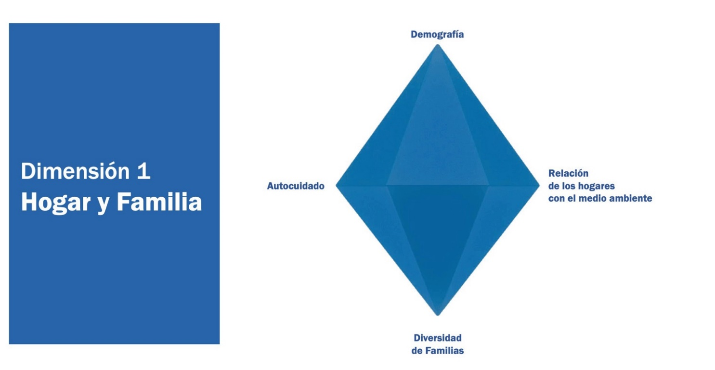  
Own elaboration

**Figure 4 - New dimensions of the care diamond - Dimension 2: Status**

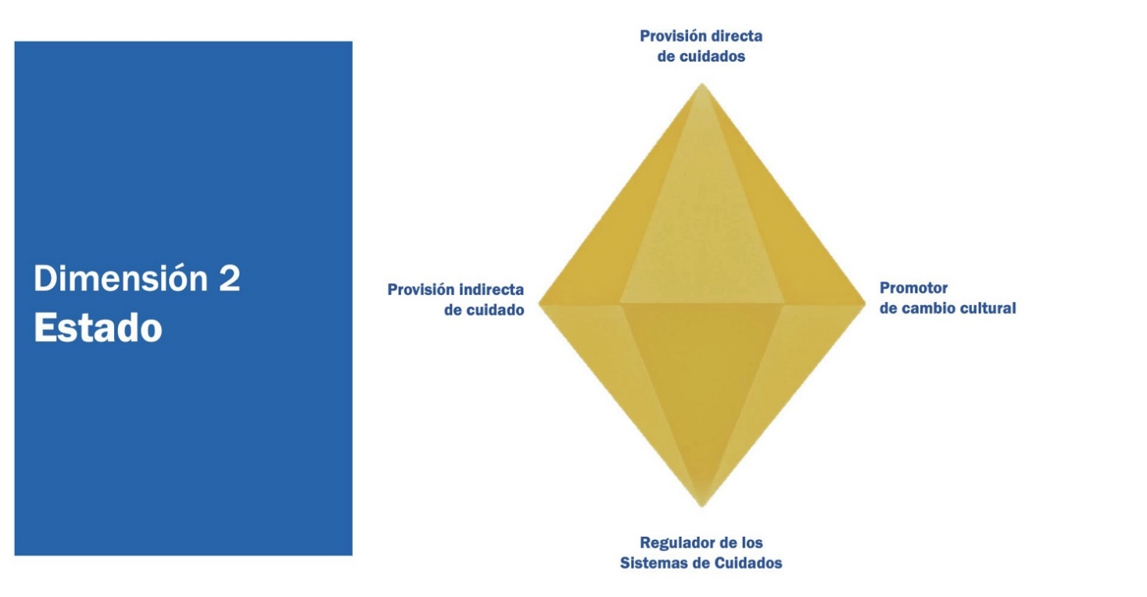

Own elaboration

**Figure 5 - The new dimensions of the care diamond - Dimension 3: Marketplace**

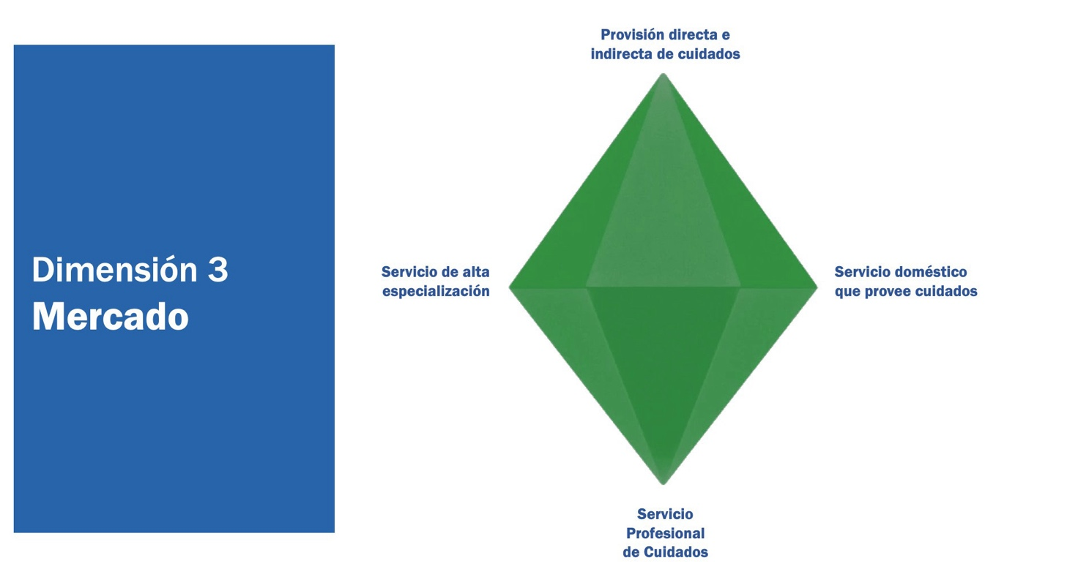  
Own elaboration

**Figure 6 - The new dimensions of the care diamond - Dimension 4: Not-for-profit**

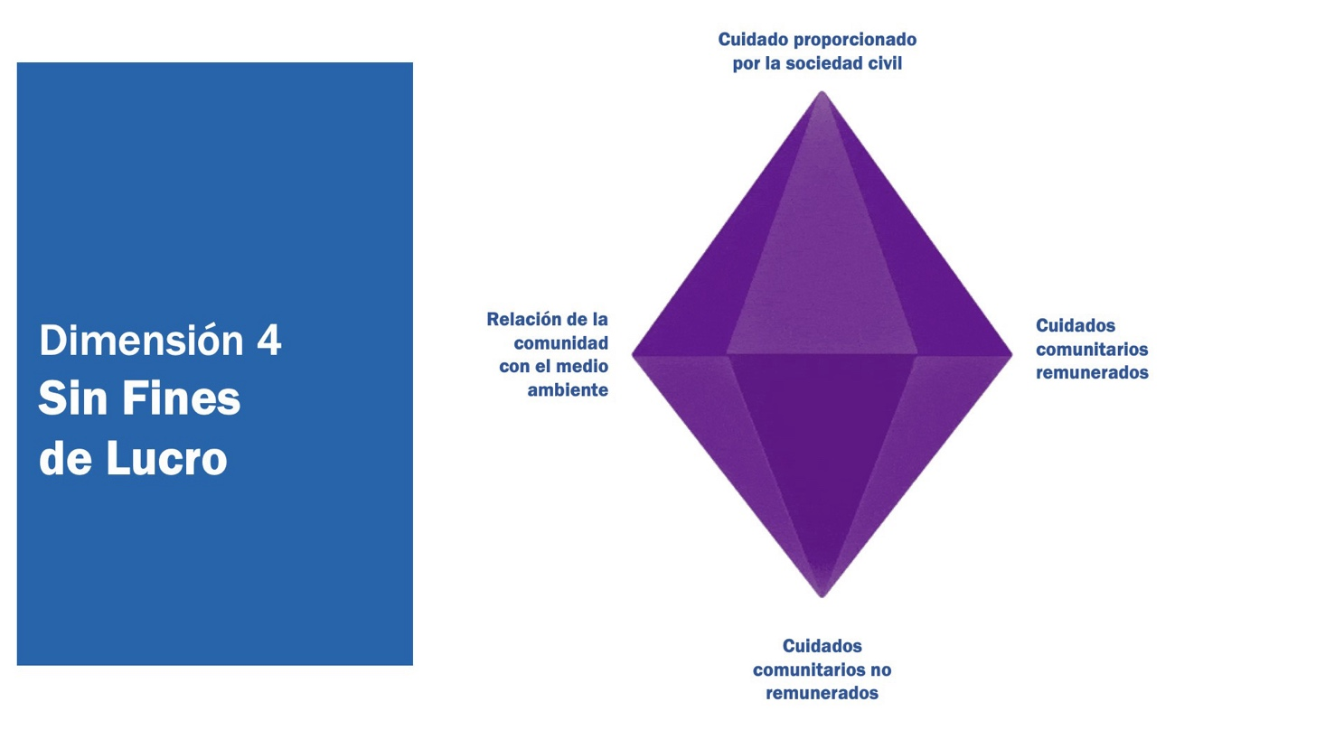  
Own elaboration

**Figure 7 - The new dimensions of the diamond of care - Understanding the prisms of care**

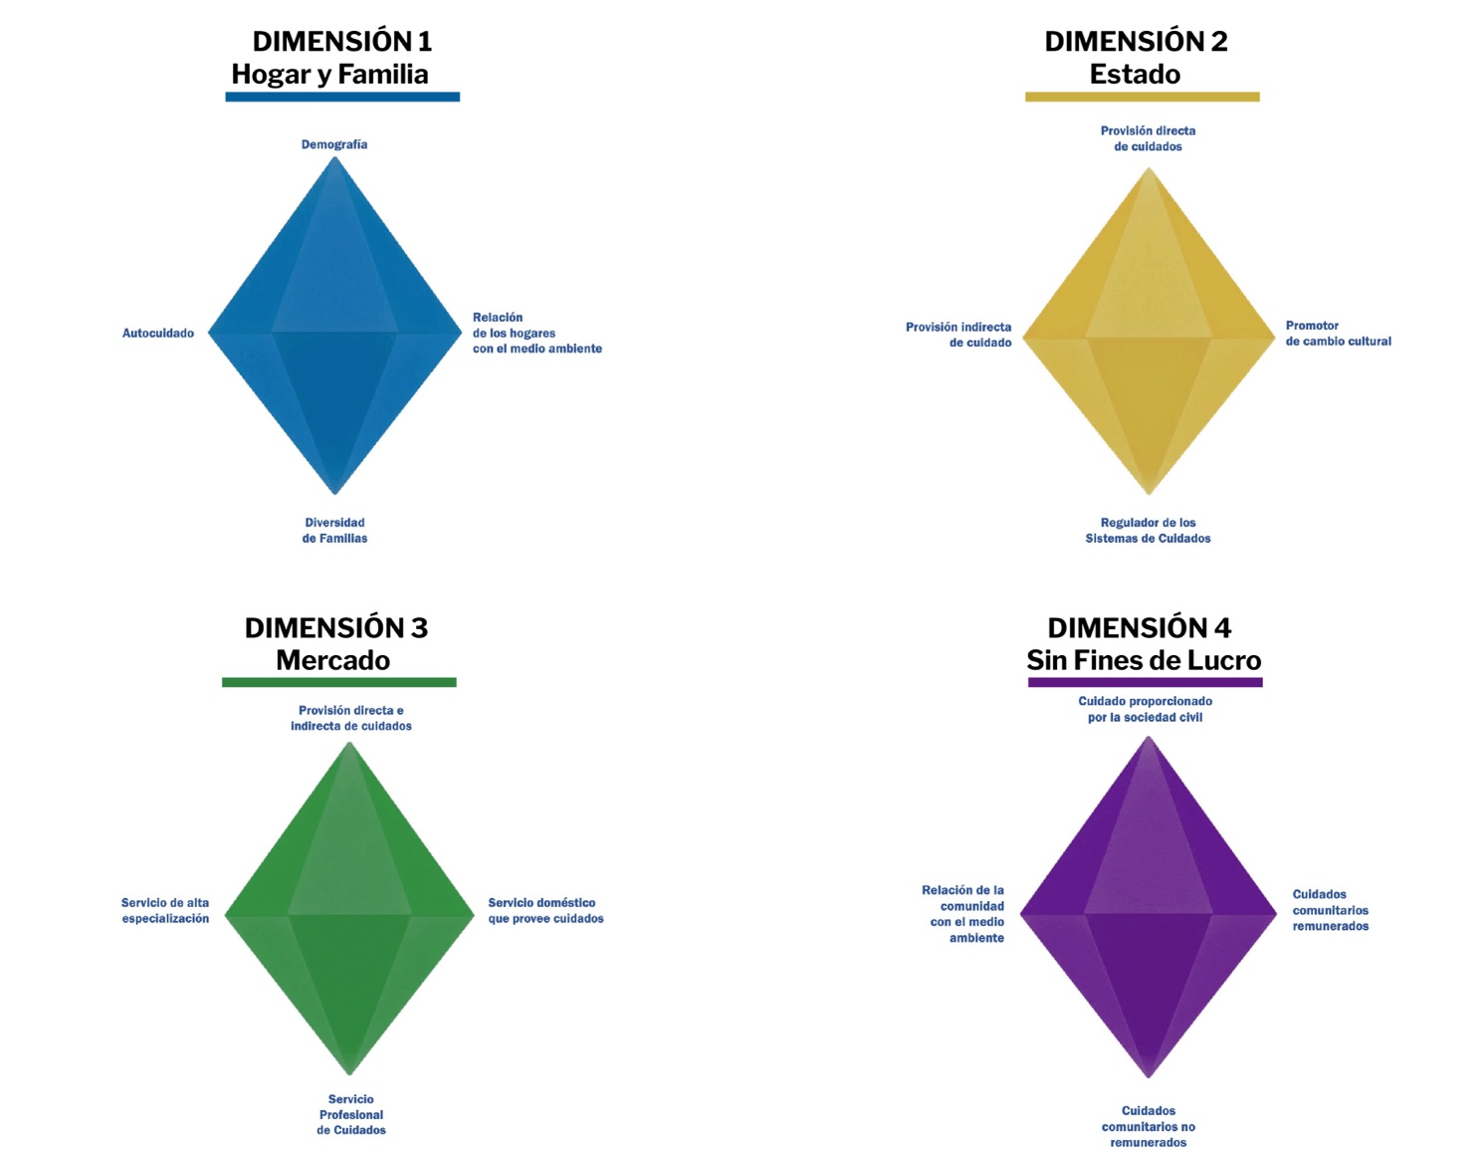

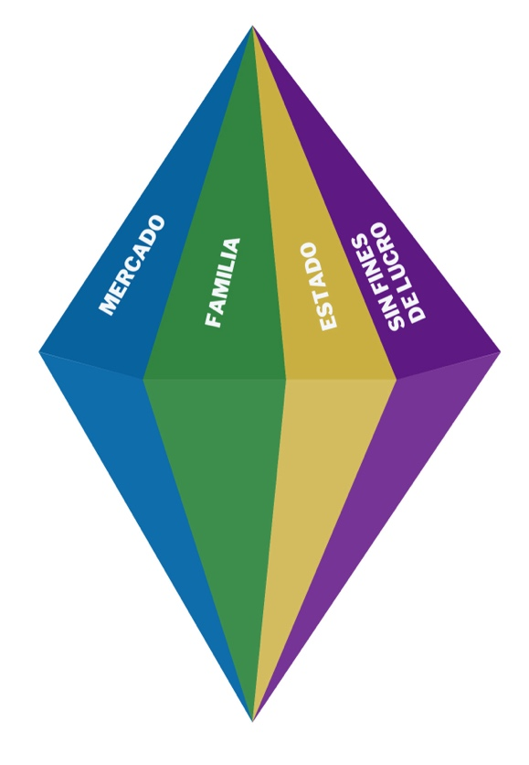

Own elaboration

On the other hand, Razavi's (2007) care diamond may lend itself to a dissociated interpretation between the distributions of care in the different spheres or sectors in which care and its institutionalization occur. Reconsidering the interconnections of the sectors in which care distributions converge is important for the implementation of strategies and policies. The care-climate nexus approach assumes that the interconnections and relationships between the diamonds that reflect the distributions of care in different sectors are not a sum of parts effect, but constitute a single body in which these distributions take place.

Thus, policies designed under the care-climate nexus do not address care needs in isolation, but rather in an intersectional, intersectoral and interconnected manner. This comprehensive approach also aims to transform cultural mandates of femininity and masculinity, and the valuation of tasks naturally associated with the feminine, linking these efforts directly to the broader challenges of climate change and environmental sustainability.

The different sectors, such as education, health, housing, or transportation, to mention a few, in which care distributions occur, are interrelated. Therefore, the linkages and effects of policies (whether climate action, health, education, labor, or economic) on the distribution of care, and vice versa, must be conceptualized as part of the same integrated body. It is not a sum of policies belonging to different sectors, it is the integration of policies corresponding to different sectors, which adds a new dimension to the two-dimensional diamond and turns it into a new prism of care (see Figure 8). **Figure 8**)

Thus, under this logic, policies designed under the care-climate nexus would not address care needs in isolation, but in an intersectional, intersectoral and interconnected manner (Box 4 provides an example). The *two-dimensional care diamond*, which distributes care provision among various institutions, can be revisited and evolve into a *prism of the care-climate nexus* that reflects the interdependence between care and environmental sustainability, adding dimensions to be explored.

In addition to the above, by considering the human rights approach in the conceptualization of the care prism, care could be recognized as a need and a right, and allows integrating into a single body the different aspects/areas of care. Pautassi (2018:738) has highlighted the importance of thinking about the steps required to build a strategic agenda that allows implementing the exercise of rights of each person to care, to be cared for and to self-care. In turn, the use of a social protection framework, as an instrumental arm, would allow moving the prism of care from a mere conceptual tool to the operationalization of policies. A social protection system could be the vehicle for integrating interrelated, comprehensive and transformative actions that address the climate-care nexus.

**Figure 8 - Nexus approach to care-climate dimensions: from care diamonds to the prism of intersectional, intersectoral and interconnected policies.**

Own elaboration based on Razavi's care diamond (2007).

The conjunction of human rights and social protection approaches allows us to overcome the barriers sometimes imposed on the human rights approach - as they emphasize normative (legal) notions of obligation and responsibilities (Deneulin, 2009) - and to highlight the role of institutional frameworks and public policies that enable the fulfillment of rights, examining and transforming the economic, social, political and cultural institutions that improve the fulfillment of these rights.

**Box 3 - The prism of care. An exercise in conceptualizing and integrating sectoral, intersectional and interconnected policies.**

|  |
| --- |
|  |

# Revisiting care-climate issues. A consequence of the nexus approach

The intersection between care and climate reveals the need to adopt an integrated perspective that considers the deep interconnections between these two domains. This is not simply a thematic overlap, but an associative relationship in which care strategies can significantly influence climate policies and vice versa. This nexus approach enables a holistic understanding of how care dynamics impact the natural environment and how climate change redefines care responsibilities and practices, especially in rural contexts and vulnerable communities (MacGregor et al., 2022).

In this sense, Box 5 summarizes some aspects and actions to be considered for the transition from the isolated approach to a care-climate nexus approach that were identified, most of them, through a participatory process promoted by the Climate Care Initiative .[9]

**Box 4 - From the isolated approach to the care-climate nexus approach, a first roadmap.**

|  |  |
| --- | --- |
| Key aspect | Shares |
| Definition and scope of care | * Broaden the definition of care to include both direct and indirect care activities, also encompassing care for communities, the planet, ecosystems and natural resources. * Collaborate with international bodies such as ILO, WHO to harmonize definitions of care and care work globally, ensuring that they are incorporated into policy frameworks and research methodologies. * Include self-care in accordance with the Commitment of Buenos Aires |
| Integration with climate policies | * Integrate care definitions and policies into climate change strategies and policies to better reflect the impacts of climate change on development and well-being. * Incorporate, as relevant elements, care considerations into climate adaptation and mitigation strategies and actions, and vice versa. This means that climate policies should integrate the importance of care into their plans, and that care strategies should take into account the impacts and challenges of climate change. This two-way approach ensures that care for people, communities, and the environment is recognized and promoted in both contexts, strengthening resilience and climate justice. * Promote the inclusion of care work in national accounts systems, recognizing its economic value and contribution to GDP, to integrate care in climate finance planning and to achieve a holistic and sustainable approach. |
| Valuation and compensation of care work | * Reassess and improve frameworks for valuing and compensating care work, linking them to climate change to recognize its impact on community resilience, through policies that integrate care into adaptation and mitigation strategies. * Develop policy frameworks that support equitable labor practices and provide social protection for care workers, integrating them into climate adaptation and mitigation strategies. |
| Innovative local solutions | * Promote the development of community care centers that function as spaces for local climate action and the provision of care services. * Visibilize and promote success stories of locally-led adaptation principles (locally-led adaptation[10] ) that integrate care and climate change. |
| Paradigm shift towards care-driven development | * Advocate for rethinking economic systems to prioritize well-being and sustainability. * Emphasize the role of care work in supporting all sectors of the economy. * Rethinking the climate-energy poverty-care trinomial |
| Comprehensive research and policy action | * Conduct extensive research to understand the climate-care nexus, particularly in the Global South. * Use the results of the climate-care research agenda to inform policies that address care needs and climate impacts. * Improve time-use surveys, and other data collection methods, to better capture the scope and impact of care work, including care for the planet. |
| Human rights-based approach | * Adopt a human rights-based approach that recognizes care as a fundamental need and right and integrates it into climate action policies. * Align care policies with rights to a healthy environment and promote social justice. |
| Social protection system | * Incorporate care as one of the pillars on which the policies and programs that make up the social protection system are designed and implemented. * Strengthen the tools provided by a social protection system to incorporate and channel the rights-based approach in care and climate change policies. |
| Investments | * Investments in mitigation and adaptation infrastructure with a gender focus and consideration of care work. * Finance fair agricultural, rural energy, water governance and public infrastructure policies that facilitate access to care, while promoting climate resilience. |

There are key areas that highlight the importance of these intersections, including environmental care, just transition and economic empowerment, financing a green and solidarity economy, community care, redistribution, and cultural change. Environmental care addresses how care work extends beyond the household, involving women and girls in the protection and management of ecosystems in both rural and urban contexts. Just transition and economic empowerment focuses on creating sustainable jobs that also consider the equitable redistribution of care work. Funding discusses how macroeconomic policies must incorporate care work to achieve true sustainability (UN Women, 2023).

In line with this approach, the International Monetary Fund (IMF, 2024) has highlighted the importance of fostering a green transition that integrates a gender perspective, underlining the strategic role played by the inclusion of women in green jobs sectors, historically dominated by men. The IMF also stresses that the economic empowerment of women in these sectors has the potential to contribute significantly to the reduction of the wage gap, as reflected in the wage premium differential in these jobs. In this context, it emphasizes the need to formulate policies that promote greater female participation in STEM disciplines and in the sustainable labor market, with the aim of ensuring that the transition to a low-carbon economy is both inclusive and equitable.

Similarly, community care and intersectionality highlight the importance of community networks in the global South, while redistribution and cultural change examine how changes in cultural mandates of femininity and masculinity can facilitate a fairer distribution of care work. Each of these areas will be examined to suggest how an integrated care and climate approach can simultaneously address gender justice and environmental sustainability; in the interest of finding more equitable and effective solutions to the challenges presented by these crises (MacGregor et al., 2022; UN Women, 2023).

### Environmental care

One reflection that emerges from the intersection between climate and care is that the correlation between reproductive work and domestic space does not fully apply to certain contexts, especially rural, low-income contexts that are particularly vulnerable to climate change and environmental degradation. This is the case, for example, with "environmental care", i.e., a type of care work that "...includes activities outside the household necessary for provisioning and subsistence, considering the care of animals, plants and common spaces on which households depend..." (MacGregor et al., 2022:1).

The delimitation of care activities outside the domestic space is not only relevant because of the additional burdens faced by women and girls as a consequence of the climate crisis, but also because it invisibilizes their fundamental role in the sustainability of ecosystems and community life. Arora-Jonsson (2021) stresses that this *invisibilization* is intrinsically linked to the masculinization of forest spaces and development activities, which have historically been defined in terms of economic production, dismissing the daily care work performed by women. This exclusion of care from the formal framework of natural resource management not only reproduces gender inequalities, but also reinforces power structures that marginalize women and perpetuate structural violence in forest and community settings (Arora-Jonsson et al., 2021).

It is urgent to reconsider the sexual division of labor (productive/reproductive work), and to start calibrating not only aspects such as time poverty derived from the above, but also the aggravated and multiple impact of the climate and environmental crisis.

### Just transition and economic empowerment

When designing "gender-sensitive" climate actions from a development perspective, it would be diligent to show some caution with the scope of those projects that focus solely and exclusively on women's economic empowerment, leaving aside other inequalities, such as the unequal distribution of unpaid care work or time poverty. This last point is important, since a just transition with a gender perspective should address the plethora of causes that produce gender inequalities, and not rely on success by designing measures for only one of them, however important it may be.

Velicu and Barca (2020) have denounced the privileges and limitations of just transition, and its inability to adhere to truly democratic and sustainable models. This being the case, and as UN Women (2023) has unequivocally stated, in addition to renewable energy and sustainable agriculture, "care as a public good is central to any reflection on a just transition to a low-emission, climate-resilient economy, as well as to a gender-sensitive just transition."

Certainly, the care sector is key to designing a just transition with a gender perspective, since, on the one hand, the transformation of the economy into a sustainable economy will demand jobs with a low carbon footprint, such as those related to care (Diski, 2022), and, on the other hand, a just transition will have to take special account of the creation of new jobs (given the destruction of jobs in specific sectors characterized by their high carbon emissions), as well as the redistribution of unpaid care and decent jobs for women, a just transition will have to take special account of the creation of new jobs (given the destruction of jobs in specific sectors characterized by high carbon emissions), as well as the redistribution of unpaid care and decent jobs for women - all aspects that can find in the care sector a not inconsiderable outlet.

Along these lines, the International Monetary Fund (IMF) has warned that men occupy approximately 70% of the jobs with the highest levels of pollution globally, suggesting that they face the greatest risks in the transition to a cleaner economy due to the closure of polluting industries to meet net-zero emissions targets. However, the transition to a cleaner energy matrix also presents significant risks for women, due to their low representation in green jobs sectors. This situation is related to the limited participation of women in disciplines linked to science, technology, engineering and mathematics (STEM), which are essential for accessing these sustainability-oriented jobs (MFI, 2024).

The MFI analysis indicates that the underrepresentation of women in green jobs may limit their economic empowerment, despite the fact that these jobs offer a higher wage premium for women (12%) than for men (7%). This wage premium differential suggests that green jobs present a concrete opportunity to reduce the gender wage gap compared to other sectors of the economy. Despite this wage incentive, women occupy only one-third of the workforce in green jobs, reflecting the persistence of barriers to their full integration in this emerging area of the economy. Against this backdrop, the IMF stresses the importance of promoting policies aimed at STEM education and gender equality in the labor market, as these can enhance women's economic empowerment in the green transition. According to the analysis, countries with a higher number of STEM-trained women workers and egalitarian policies tend to experience faster and more effective transitions to a green economy. In addition, these policies allow increasing the effectiveness of climate policies by expanding the supply of skilled labor in sustainable sectors and promoting green innovation (IMF, 2023).

A just transition with a gender focus must include both the creation of sustainable jobs and the equitable redistribution of care work and the economic empowerment of women, recognizing care as an essential public good in these policies.

### Financing

The transition to a green and solidarity economy requires fundamental changes in the way our economies and societies are organized, produced and reproduced. A key component of these changes is the redesign of financial and fiscal policies. These policies determine, for example, how the public sector invests in physical and social infrastructure, how governments use taxes and subsidies to support or impede certain types of economic activities, as well as how the financial system provides credit to the real economy. Macro-financial policies thus have important implications for gender equality, our well-being and the environmental effects of economies.

When assessing progress in this area, feminist studies tend to agree that these policies often do not take into account the central role that care plays in the functioning of economies and societies. In turn, this gap also determines decision-making in financial and fiscal matters (Nikolaidi, 2022). In other words, they ignore not only that care work is the work that makes all other work possible, but that most decarbonization policies (in energy, technology, etc.) can exacerbate gender inequalities, even though investment in quality care services could achieve the above without impacting women in this way. In short, the logic governing decarbonization from a financial and fiscal point of view does not adequately take into account and address the care crisis and gender inequalities.

### Community care

Another aspect that has received significantly little attention is the non-profit care organization (Fraga, 2022). The fact that this vertex of Razavi's diamond (2007) has attracted less interest in the distributions of care may be due to the predominance of the other three vertices (family, market and state) in high and upper-middle income countries. The polysemy of the term does not help either, giving rise to multiple modalities and hybridizations[11] and, in any case, strongly marked by territoriality and the situation/context of origin.

It is important to bear in mind, however, the fact that community care work continues to play a key role in other regions, such as those belonging to the global South, in low and lower-middle income countries, and in rural contexts (although not only). Not surprisingly, considering the funding challenges that would involve the implementation of public care policies in countries with reduced fiscal space and the remote possibilities to particularly meet these needs in the market[12] , community work service networks operate as an instrument that can help reduce part of the unpaid domestic and care work performed by women and girls (Lopez and Cielo, 2018).[13]

However, it is important not to fall into idealizations. Community work can indeed realistically reduce the care work of women and girls in the short term with existing means, but it does not necessarily guarantee redistribution or remuneration. It is no coincidence, in this respect, that it is mainly women who are in charge of these community networks. It is precisely for this reason that it is necessary to question their configuration, their conditions of equality, their organization, the participation of their members and their values and performance (Federici, 2013).

### Redistribution and cultural change

The usefulness of community care work as a viable short-term measure to reduce the domestic and care work of women and girls was mentioned earlier, and its value was highlighted precisely in view of the difficulty of this change being produced by a redistribution that is, in turn, a consequence of a cultural change in gender cultural mandates. Well, despite its potential (although undoubtedly in the medium and long term), this area has not been particularly researched either (MacGregor *et al.*, 2022: 85).

From the few studies conducted, it has been noted, however, that crisis situations have provided an opportunity to redefine the gender roles and burdens associated with different types of work, promoting a more equitable arrangement between women and men (Jerneck, 2018). On this aspect, there are some recipes usually implemented in the global North and in middle- and high-income countries, which have proven their effectiveness as a lever of intervention to implement an egalitarian cultural change of greater depth; this is the case of policies focused on care and work/life balance.

That said, it is important not to overlook the social and economic context analyzed here. Well, despite the scarce research on this issue, and after comparing strategies to implement this type of projects with the adhesion of the communities in which these are to be carried out, some research warns, for example, that programs on parity care are more likely to be accepted by the local population if the benefits are made evident to the entire community, thus avoiding the drawbacks of approaches that only target women (Bryan *et al.*, 2018).

In rural contexts, however, there are community-based cultural practices, where agriculture is carried out with a community conception and differentiated gender roles. In these communities, care tasks such as water collection are mostly carried out by women, a dynamic that climate change threatens to aggravate (UN Women, 2021).

In any case, greater equality in domestic and care work cannot be achieved if it is not accompanied by greater co-responsibility on the part of men. And, although cultural change is complex and lengthy (UN Women, 2023b), working with men and boys in this regard is essential.

Likewise, it would be useful to have evidence and solid arguments to try to disarticulate the campaigns coming from neoconservative and negationist fronts, whose alliance at the global level has the fundamental purpose of neutralizing and, if possible, reversing all the emancipatory agendas set in motion over the last few years (feminist, environmentalist, trade unionist, etc.); and to position such evidence in the media and social networks, but also in other spheres of power such as international organizations, NGOs, academia, think tanks, etc. (McEwen and Narayanaswamy).); and to position such evidence in the media and social networks, but also in other spheres of power such as international organizations, NGOs, academia, *think tanks*, etc. (McEwen and Narayanaswamy, 2023).

# Identifying critical intersections between the impacts of the care and climate crises

Understanding the intersections between the care crises and the climate crisis has been discussed through a participatory process, coupled with an extensive literature review, and has revealed a number of critical dimensions that are fundamental to addressing these crises in an integrated and holistic manner. These dimensions not only reflect the areas of greatest impact and vulnerability, but also offer significant opportunities to deepen research and develop policies to close existing gaps.

The choice of these dimensions, which is not categorical, is based on their relevance to understanding how the climate crisis and the care crisis intersect and amplify each other. The nexus approach used in this analysis allows for a comprehensive and coordinated view of the interrelationships between these factors, highlighting the need for integrative policies that can address multiple challenges simultaneously. As will be seen, these intersections occur in many and across almost all areas, underscoring the urgency for multifaceted and collaborative approaches (Box 6 synthesizes the critical intersections between the impacts of the care crisis and the climate crisis).

**Gender equality**

Women and girls assume most of the unpaid care work, which limits their participation in the labor market and perpetuates economic and social inequalities. These responsibilities restrict the time available for education and paid employment, keeping them in a position of economic disadvantage. The lack of recognition and valuation of care work contributes to maintaining these structural inequalities. For their part, climate disasters increase care burdens due to illness, displacement and the need to collect resources, exacerbating gender-based violence and the exclusion of women in climate decision-making.

**Economic sustainability**

Lower female labor participation and income inequality due to caregiving responsibilities perpetuate poverty and limit access to economic resources. These economic inequalities are exacerbated by the climate crisis, which increases unemployment and poverty in female-dominated sectors such as agriculture and informal work. Climate disasters increase food costs and reduce the overall economic capacity of affected communities, exacerbating poverty and limiting women's economic resilience (World Bank, 2021; FAO, 2020).

**Social justice**

Caregiving responsibilities perpetuate gender inequity and limit equitable access to basic resources and services, exacerbating social and economic vulnerabilities. Social justice policies often exclude women, exacerbating inequalities in access to resources and services, and increasing women's vulnerability in disaster situations (UNDP, 2019; IPCC, 2022).

**Fair transitions**

Transitions to sustainable economies increase care burdens for women, who face additional barriers in adapting to new green jobs and technologies. Unequal distribution of the benefits of green jobs and lack of resources for adaptation increase women's vulnerability during economic transitions. The intersection of these care responsibilities and economic barriers limits women's ability to benefit from transitions to a more sustainable economy (ILO, 2021; OECD, 2020).

**Health and wellness**

Care burdens increase the incidence of disease among women, limiting their economic capacity and access to health services. Climate disasters aggravate these conditions, not only exacerbating disease and reducing food production, but also affecting the mental and physical health of women, who often have unequal access to health services.

In addition, disasters directly impact the very infrastructure of health services, as well as other essential systems such as energy and transportation, which further exacerbates the burden of care work, as women are forced to assume greater responsibilities in the face of decreased access and adequate functioning of these services.

These combinations of care responsibilities and climate-related diseases increase the burden of disease and limit access to adequate health services, underscoring the need to integrate health and well-being into climate and care policies (WHO, 2022; UNICEF, 2021).

**Food safety**

Women and girls are more vulnerable to food insecurity due to their caregiving roles, which limit their access to food and productive resources. Reduced agricultural production due to extreme weather events severely affects food security, increasing malnutrition and associated care burdens (WFP, 2021; FAO, 2020).

**Access to natural resources**

Collecting water and firewood, for example, increases women's time and effort, perpetuating dependence on traditional energy resources. Degradation of essential natural resources, time spent on ecosystem conservation and competition for scarce resources increase women's vulnerability, limiting their time for education and other productive activities. This combination of increased burden of resource collection and competition for scarce resources increases this vulnerability (UN Women, 2023; UNEP, 2020).

**Education**

Caregiving responsibilities cause girls and women to drop out of school, perpetuating cycles of poverty and limiting their future opportunities. Natural disasters disrupt education, especially affecting girls, who already face additional barriers due to their caregiving roles. This intersection perpetuates educational inequality and limits opportunities for women and girls (UNESCO, 2020; UNICEF, 2021).

**Migration and displacement**

Women and girls displaced by climate disasters face increased risks of exploitation and abuse, exacerbated by their caregiving responsibilities. Forced displacement due to climate disasters increases vulnerability and risks of violence for women, who have limited access to resources and services in displacement contexts. This combination of forced displacement and care responsibilities increases vulnerability and risks of exploitation and abuse for women and girls (UNHCR, 2022; IOM, 2021).

**Governance and policy**

The exclusion of women from decision-making on care policies perpetuates inequalities and limits the effectiveness of responses to crises. The lack of women's representation in climate policies exacerbates inequalities and limits the implementation of inclusive and equitable solutions (UNWomen, 2023).

**Gender violence and security**

Stressful situations increase domestic and community violence, seriously affecting women in their care-giving roles. In this line, the effects of climate change exacerbate such violence, affecting the security of women and girls in crisis contexts (UN Women, 2023; UNFPA, 2021).

**Box 6 - Critical intersections between the impacts of the care and climate crises**

|  |  |  |  |  |
| --- | --- | --- | --- | --- |
| **Impact of the Care Crisis** |  | **Intersection** |  | **Impact of the Climate Crisis** |
| Increased unpaid work for women and girls | **→** | **Gender Equality**  Increased burden of care during disasters; increased violence | **←** | Gender inequality exacerbated in disaster situations |
| Lower paid female labor force participation, income inequality | **→** | **Economic Sustainability**  Unemployment and poverty aggravated by caregiving responsibilities | **←** | Job losses in climate-affected sectors |
| Care burdens perpetuate gender inequity | **→** | **Social Justice**  Increased social and economic vulnerability | **←** | Unequal access to resources in crisis situations |
| Increased caregiving responsibilities | **→** | **Just Transitions**  Barriers in access to green and sustainable jobs | **←** | Inequality in the distribution of benefits from green jobs |
| Increase in family caregiver-related illnesses | **→** | **Health and Wellness**  Increased demand for medical care and disease burden | **←** | Increase in diseases related to climate change |
| Women and girls most affected by food insecurity | **→** | **Food Safety**  Unequal access to food during disasters | **←** | Reduced agricultural production and access to food |
| Increased time and effort in water and firewood collection | **→** | **Access to Natural Resources**  Shortage of natural resources increases harvesting burden | **←** | Deterioration of essential natural resources |
| Dropping out of school due to caregiving responsibilities | **→** | **Education**  Reduced access to education and increased school dropout rates | **←** | Disruption of education due to natural disasters |
| Women and girls more vulnerable to exploitation, violence and abuse during displacement | **→** | **Migration and Displacement**  Increased violence and exploitation in displacement contexts | **←** | Forced displacements due to climatic disasters |
| Women excluded from care policy decisions | **→** | **Participation in Decisions**  Lack of inclusion in policy decision making | **←** | Lower representation of women in climate policies |
| Increase in domestic and community violence | **→** | **Gender Violence and Security**  Increased vulnerability in disaster situations | **←** | Increase in gender-based violence during climate crises |
| Lack of access to clean and affordable energy | **→** | **Energy and Resources**  Increased use of traditional and polluting resources | **←** | Environmental degradation and increased emissions |
| Lack of representation of women in care decisions | **→** | **Governance and Policy**  Non-inclusive and unequal policies | **←** | Lack of inclusion of women in climate policies |
|  |  |  |  |  |

# Conclusions

Recognition of the interconnection between climate change and care, as has been seen, is critical to effectively address today's socioeconomic and environmental challenges. Policies and programs that have so far addressed climate change and care in isolation have proven insufficient to mitigate the negative effects and take advantage of the opportunities arising from their integration. The transition to a care-climate nexus approach requires a paradigm shift in the way socioeconomic and environmental policies are conceived and designed.

Therefore, it is necessary to understand that care is an integral part of community resilience and environmental sustainability. The overburden of care work not only limits women's ability to participate in the labor market and climate decision-making, but also increases the vulnerability of households and communities to the impacts of climate change. Integrating climate policies with care policies can therefore generate multiple benefits.

To achieve this transition, several aspects and actions must be considered. First, it is essential to redefine and broaden the concept of care, including all essential activities that support well-being and formally recognizing the rights of domestic and care workers. This recognition is not only an act of social justice, but also a fundamental step towards valuing care work in national accounts, more accurately reflecting its contribution to the economy and climate resilience.

The integration of climate policies with care policies must include climate adaptation and mitigation strategies specific to care. This implies developing climate-resilient care infrastructures and public services, which would not only reduce the burden of unpaid care on women, but could also generate green jobs and promote sustainable economic development. In addition, it is essential to re-evaluate the valuation and compensation frameworks for care work to promote fair labor practices and provide adequate social protection for caregivers.

Creating innovative local solutions also plays a crucial role in this transition. Developing climate-resilient community care centers and promoting successful local models of care and climate change integration can serve as replicable examples. These solutions must be contextually relevant and culturally sensitive to ensure their effectiveness and long-term sustainability.

The paradigm shift to care-driven development prioritizes well-being and sustainability in economic systems. Recognizing the critical role of care work in all economic sectors is essential for a just transition. In addition, comprehensive research and policy action are needed to better understand the interaction between climate and care. Improving data collection on time use and care work is a crucial first step.

Adopting a human rights-based approach, enhanced by a social protection framework, is fundamental. Recognizing care as a fundamental need and right, and aligning care policies with the rights to a healthy environment, will drive the implementation of multisectoral and coordinated public policies that guarantee fair and equitable solutions in the different areas of development.

Achieving a virtuous circle would therefore involve promoting key social protection and care policies to ensure women's security and well-being, and providing the right conditions for their participation in the labor market, as well as transforming gender norms. Similarly, competency and skills development policies would be critical to avoid occupational segregation and ensure that women and girls benefit from new employment opportunities in a green and blue economy.

## Research opportunities and challenges

As we have seen, we are facing a series of multidimensional crises that span the health, social, political, economic, trade and environmental spheres. These crises not only accompany, but also aggravate the care crisis (ECLAC, 2024). The care crisis underscores the essential interdependence between people and generations for the sustainability of societies. We have seen that the different crises intensify care work, significantly impacting health and well-being by exacerbating pre-existing vulnerabilities. [14]

It becomes necessary to develop a new research agenda that explores these intersections in greater depth. This agenda should address how the multidimensional crises interrelate and exacerbate the care crisis, assessing the effectiveness of integrated policies that promote sustainable and equitable development. It should also focus on the strategies needed to reduce gender inequalities, improve care infrastructure, and foster cultural change that challenges existing gender norms.

Along these lines, there is an urgent need for systematic, longitudinal studies that explore how climate change impacts care work (both paid and unpaid) and vice versa. Research must address the multiple dimensions of this intersection, providing a comprehensive framework for understanding the underlying dynamics. In this way, it becomes critical to highlight the importance of caring for people and the planet together to ensure the sustainability of societies.

The gender equality and climate change agendas are usually developed separately and, despite the particular mentions that may be made, their inseparable nature is just beginning to be visualized and conceptualized politically. It is therefore necessary to standardize their integration. Research is needed to quantify and economically value care work in relation to the impacts of climate change. This will allow a better understanding of how climate shocks affect the care economy and vice versa, facilitating the formulation of more effective and equitable policies.

It is important to continue to work on changing the cultural mandates of femininity and masculinity in order to achieve a greater commitment on the part of men to redistribute caregiving. New studies should focus on identifying effective strategies to redistribute care work in contexts affected by climate change, identifying practices and policies that promote an equitable distribution of care responsibilities between men and women.

The effectiveness of climate policies in promoting gender equity and reducing the burden of care needs to be thoroughly evaluated. How current policies address (or fail to address) these inequalities should be investigated and substantial improvements proposed.

Community care networks play a crucial role in resilience in the face of climate shocks. It is essential to investigate how these networks can be strengthened and supported, and which models of community care are most effective in different contexts, especially in rural and low-income areas. However, any intervention must avoid the reproduction of traditional gender roles and the perpetuation of the sexual division of labor. Furthermore, the strengthening of these networks must not exempt the state from its responsibility to provide essential public services, including care policies and climate action.

The relationship between climate change-forced displacement and the burden of care work is an underexplored area. Studies are needed that analyze how displacement impacts care provision and responsibilities and what policies can mitigate these effects.

The mental health of caregivers in climate crisis contexts is a critical dimension that has received little attention. Research in this area should address the emotional and psychological impacts of caregiving during and after extreme weather events.

Local innovations and practical adaptations that integrate care and climate resilience should be documented and analyzed. Successful case studies and lessons learned can provide replicable models and evidence-based information in different regions.

The integration of gender and climate considerations into financial and public policy models is critical. There is a need to develop and evaluate fiscal and financial policies that support both gender equity and environmental sustainability.

Social and cultural norms significantly influence the distribution of care work and climate resilience. Studies in this area should explore how to transform these norms to foster greater co-responsibility and equity in care, including environmental care, effects for climate action.

Integrating human rights-based approaches into climate and care policies is essential. Research should focus on how policies can ensure equitable access to essential resources and services in contexts of climate change.

It is relevant to investigate how climate change adaptation and mitigation strategies can be integrated with care policies. This includes exploring how climate-resilient infrastructures can reduce the burden of care work and how care practices can contribute to climate resilience.

The relationship between gender-based violence, care work and climate change is a critical area that requires attention. Studies are needed that examine in greater depth how climate events increase women's vulnerability to gender-based violence and how the additional burden of care in these contexts may exacerbate this situation.

Studies evidencing the effects of climate change on care have been gaining ground in the academic and public policy agenda. However, causal analyses of the effects of care and care policies on variables associated with climate change are rare. Understanding the effects of care distributions and care policies on mitigation, adaptation and environmental sustainability is important for improving the design and implementation of inclusive and sustainable development policies, and is central to the climate-care nexus approach.

Finally, one of the biggest challenges is the collection of gender-disaggregated data and other socio-demographic indicators to fully understand these impacts and develop targeted and effective policies. The availability of robust and disaggregated data would allow for a more accurate assessment of the dynamics of care and its intersection with other crises, thus informing decision making and advocacy for the creation of public policy models that consider both care needs and environmental challenges and all those intersecting dimensions. Improving data collection and methods of measuring care work in contexts affected by climate change is critical. This includes quantifying environmental care, developing more accurate metrics to capture the scope and impact of care work in different communities.

These identified research gaps and areas for further research (summarized in Box 7) will enable a more complete and effective understanding of the interconnections between climate change and care work. Addressing them will enable the formulation of more inclusive and sustainable policies, improving the resilience and well-being of communities in the face of climate challenges. To this end, it is recommended to:

* Rethink an updated framework for the 5Rs that includes specific actions to care for the planet in a comprehensive manner.
* Increase *bottom-up* research and case studies with the aim of making the climate-care intersection more visible and broadening knowledge of it.
* Rethink the "care diamond" and the co-responsibility of care actors in light of the constraints imposed by the nation-state (global problems, multilateralism, etc.) or cultural norms (hegemony and ubiquity of patriarchal gender mandates).
* Sizing up all facets of care work in the global South, low and middle-income countries, rural areas. For example, "environmental care".
* Evaluate pros and cons of the measures usually designed in fair transitions for women (prioritizing female empowerment) in order to build more comprehensive and egalitarian proposals (addressing the various gender inequalities).
* Data collection and development of financing and fiscal policies for a just transition with a gender perspective focused on care. The gap has barely been detected, and data and strategies are needed to build a solid argument.
* Explore the possibilities of community care to reduce care work, given the limitations in terms of fiscal space.
* Continue to focus on cultural change of gender norms to achieve greater commitment on the part of men in the redistribution of care. There is a lack of research and political commitment.
* Do not leave girls behind. The climate-care intersection affects them directly and is often forgotten in studies and just transition policies.
* Conceptually and politically articulate emancipatory agendas in a common front (feminist, ecological, anti-racist, etc.) in order to strengthen their relevance and their message to confront the negationist and neo-conservative "culture war".

**Box 5 - Synthesis of some research gaps in care-climate linkages and possible approaches to address them**

|  |  |
| --- | --- |
| **Research gap** | **Possible approaches** |
| Lack of systematic and causal studies on climate and care | Systematic, longitudinal and causal analyses of how climate change impacts care work and vice versa. |
| Economic impact of care work in the context of climate change. | Quantification and economic valuation of care work in relation to climate change impacts. |
| Empirical evidence on the redistribution of care work in the context of climate events. | Effective strategies for redistributing care work in the face of climatic disasters and environmental degradation. |
| Gender Inequalities in Climate Policies | Evaluation of the effectiveness of climate policies in promoting gender equity and reducing the burden of care. |
| Intersection between community care and climate change | Strengthening and supporting community care networks in the context of climate crisis. |
| Displacement and migration due to climate change | Impact of forced displacement due to climate change on the workload of caregivers. |
| Mental health and care work in climate crises | Impacts of climate change on the mental health of caregivers. |
| Local innovations and adaptations in care work | Local innovations and practical adaptations that integrate care and climate resilience. |
| Models of care finance and public policies | Development of financial models and public care policies that effectively integrate gender and climate considerations. |
| Impact of social norms on climate resilience and care. | Transformation of social norms to foster greater co-responsibility and equity in caregiving. |
| Data and measurement of care work in climatic contexts | Improvements in data collection and methods for measuring care work in contexts affected by climate change. |
| Intersection between climate policy and human rights | Ensure equitable access to essential resources and services in the context of climate change. |
| Climate change adaptation and mitigation integrated with care policies | Climate resilient infrastructures that reduce the burden of care work and contribute to climate resilience. |
| Gender violence, care and climate change | Impact of extreme weather events and environmental shocks on women's vulnerability to gender-based violence and how the additional burden of care can exacerbate this situation. |

# Bibliography

Adatti L., Cattaneo U., Esquivel V., and Valarino I. (2018). Care work and care jobs for the future of decent work. International Labour Organization, Geneva.

Global Partnership for Care (2024). The work of Care. Some Concepts of Care. https://globalallianceforcare.org/es/about-care.html

Anderson J. (2007). Gender of Care. In Barrig, Maruja (Ed.), Fronteras Interiores: Identidad, diferencia y protagonismo de las mujeres (pp. 71-93). Lima: Instituto de Estudios Peruanos (IEP).

Araujo N. (2024). "Looking towards a care society, but living under multiple and unequal ways of producing care: is there light at the end of that tunnel?" In Batthyány, Pineda and Perrotta (Coord.) La sociedad del cuidado y políticas de la vida. CLACSO-INMujeres-UNAM-UNRISD.

Arora-Jonsson, S., C. J. P. Colfer, and M. González-Hidalgo (2021). "[Seeing the quiet politics in unquiet woods: A different vantage point for a future forest agenda.](https://link.springer.com/content/pdf/10.1007/s10745-021-00233-0.pdf)". *Human Ecology.* Num. 49, 297-308.

Bakker I. (2007). Social reproduction and the constitution of a gendered political economy. New Political Economy 12 (4): 541-556.

Barba C., (2005). "Paradigms and welfare regimes" Flacso, Costa Rica.

Barrientos A., (2004). "Latin American: Towards a Liberal-informal Welfare Regime", in Ian Gough and Geof Wood (eds.), Insecurity and Welfare Regimes in Asia, Africa and Latin America: Social Policy in Development Contexts, Cambridge University Press, pp. 121-168, Cambridge.

Batthyány K. (2013). Time use and unpaid work: sexual division of labor and gender contracts. A case study in the rural family environment. In Piñeiro, Vitelli, & Cardeillac, Relaciones de género en el medio rural uruguayo: inequidades "a la intemperie" (pp. 81-106). Montevideo: FCS, CSIC.

Batthyány K. (2021). Políticas del cuidado. Ciudad Autónoma de Buenos Aires: CLACSO; Mexico DF : Casa Abierta al Tiempo.

Batthyány K., (2024) Challenges and opportunities of the care society in Latin America and the Caribbean. In Batthyány, Pineda, and Perrotta, La sociedad del cuidado y políticas de la vida. CLACSO-INMUJERES-UNAM-UNRISD.

Benería, L. (2006), "[Trabajo productivo/ reproductivo, pobreza y políticas de conciliación](https://dialnet.unirioja.es/descarga/articulo/3995906.pdf)". *Nómadas*. NO. 24, April, 8-21.

Bhattacharya T. (2017). Social reproduction theory: Remapping class, recentering oppression. Pluto Press.

Bryan E., Ringler C., and Mein¬zen-Dick R., (2023). "Gender, resilience, and food systems." In Resilience and Food Security in a Food Systems Con¬text. Palgrave Studies in Agricultural Economics and Food Policy.

Bryan, E., Q. Bernier, M. Espinal, and C. Ringler. (2018). "Making climate change adaptation programmes in Sub-Saharan Africa more gender responsive: Insights from implementing organizations on the barriers and opportunities." *Climate and Development.* Num 10, 417-431. <https://www.tandfonline.com/doi/abs/10.1080/17565529.2017.1301870> (n.a.).

Camps, V. (2021). [*Tiempo de cuidados*](https://isegoria.revistas.csic.es/index.php/isegoria/article/download/1220/1402). Arpa, Barcelona.

Carrasco C., Borderías C., and Torns T. (2011). Care work: historical background and current debates. In Carrasco, Borderías, and Torns (eds.), El trabajo de cuidados: historia, teorías y política. Los Libros de la Catarata.

Carrasquer P. (2013). The rediscovery of care work: some reflections from Sociology. Cuadernos de Relaciones Laborales, vol. 31 (1), pp. 91-113.

ECLAC (2024) Latin America and the Caribbean facing the challenge of accelerating progress towards the 2030 Agenda: transitions towards sustainability. ECLAC.

Cerise S., Cook S., Lehmann-Grube K., Taylor J., and Valodia I. (2024) Towards a gender just transition: Principles and perspectives from the global South. Climate Change and Inequality SCIS Working Paper no. 68, University of the Witwatersrand, Johannseburg.

Chopra, D., and E. Zambelli (2017). No time to rest: Women's lived experiences of balancing paid work and unpaid care work. IDS. <https://opendocs.ids.ac.uk/opendocs/handle/20.500.12413/13574>

Ciriza, A., Cos-Montiel, F., Eltit, D., & Lamas, M. (2022). *Living, working, caring and dying in times of COVID-19: Reflections from Latin America*. UNRISD. Available at: [https:](https://www.unrisd.org/es/library/videos/vivir-trabajar-cuidar-y-morir-en-tiempos-de-covid-19)//www.unrisd.org/es/library/videos/vivir-trabajar-cuidar-y-morir-en-tiempos-de-covid-19

CLACSO/UN Women (2022). Estado del arte sobre cuidados en contextos de ruralidad en América Latina y El Caribe. CLACSO-UN Women.

Coffey C., Espinoza P., Harvey R., Lawson M., Parvez A., Piaget K., Sarosi D., and Thekkudan J., (2020). Time to care. Oxfam International. [https://www.](https://www.oxfam.org/en/research/time-care)oxfam.org/en/research/time-care

Costa, R., Kalle, A., Avila, D. L., Magalhaes, M., Muller, M., & Salazar, E. (2023). What Works to Narrow Gender Gaps and Empower Women in Sub-Saharan Africa? An Evidence-Review of Selected Impact Evaluation Studies. World Bank, Washington, DC.

Daly H. (2014). "Beyond Growth: The Economics of Sustainable Development", Beacon Press.

Daly M. and Lewis J. (2000). The concept of social care and the analysis of contemporary welfare state. British Journal of Sociology, 51(2), 281-298.

Deneulin S. (2009) Ideas Related to Human Development. In Deneulin S. and Shahani L. (edts) An Introduction to the Human Development and Capability Approach. Freedom and Agency. Earthscan-IDRC.

Diski, R. (2022). [A green and caring economy: Feminist Green New Deal Report](https://wbg.org.uk/wp-content/uploads/2022/11/A-Green-and-Caring-Economy-Report-FINAL.pdf). Women's Budget Group (WBG) - Wen (Women's Environmental Network), London.

Economic Empowerment Section-UN Women (2023). "The Climate-Care Nexus: Addressing the Linkages Between Climate Change and Women's and Girls' Unpaid Care, Domestic and Communal Work." UN Women.

Elson D. (2017). Recognize, reduce, and redistribute unpaid care work: How to close the gender gap. New Labor Forum 26 (2): 52-61.

Esping-Andersen G. (1990). The Three Worlds of Welfare Capitalism. Cambridge: Polity Press.

Esquivel V. (2013). Care in households and communities: Background paper on conceptual issues. Oxfam Research Reports, October. Oxfam, Oxford.

FAO (2014). [The State of Food and Agriculture](https://catalogue.unccd.int/776_a-i6030e.pdf). Rome

Federici, S. (2013). [*Revolution at zero point. Domestic work, reproduction and feminist struggles*](https://traficantes.net/sites/default/files/pdfs/Revolucion%20en%20punto%20cero-TdS.pdf)*.* Madrid: Traficantes de sueños.

Ferreyra, M, (2021) "Sistema Nacional de Cuidados. Una estrategia para atender simultáneamente la crisis de cuidados y la falta de empleo remunerado", in Pluralidad y Consenso, Año 11, No. 47, Senada de la República. Mexico.

Filgueira F., (1998). "El nuevo modelo de prestaciones sociales en América Latina: Eficiencia, residualismo y ciudadanía estratificada", in B. Roberts (ed.), Ciudadanía y política social, Flacso/ssrc, pp. 71-116. Costa Rica

Floro M., Sepúlveda M. and Lozano, A., (2023) "A Care-Led Transition to a Sustainable Future", GI-ESCR/Ministry for Foreign Affairs of Finland.

Folbre N. (2006). Measuring care: Gender, empowerment, and the care economy. Journal of Human Development 7 (2): 183-199.

Folbre N. (2014). The care economy in Africa: Subsistence production and unpaid care. Journal of African Economies 23 (1): i128-i156.

Folbre N. (2018). Developing care: Recent research on the care economy and economic development. International Development Research Centre (IDRC).

Fournier, M. (2022). [Taxonomy of community care work](https://www.ilo.org/es/publications/taxonomia-del-trabajo-del-cuidado-comunitario), ILO, Buenos Aires.

Fraga, C. (2022). [Community care in Latin America and the Caribbean](https://www.ilo.org/es/publications/los-cuidados-comunitarios-en-america-latina-y-el-caribe-una-aproximacion). UNDP, ECLAC, UN Women, ILO and OXFAM.

Fraser N. (1997). Justus interruptus. New York, NY: Routledge.

Fraser N. (2013). Fortunes of feminism: From state-managed capitalism to neoliberal crisis. London: Verso.

Fraser N. (2021). Climates of capital. New Left Review 127 (Jan.-Feb.).

Fraser, N. (2016). [Contradictions of Capital and Care](https://newleftreview.org/issues/ii100/articles/nancy-fraser-contradictions-of-capital-and-care). *New Left Review*, no. 100, 99-117.

Gamble, J. L., Balbus, J., Berger, M., ... & Ziska, L.. Ch. 9: Populations of Concern. The Impacts of Climate Change on Human Health in the United States: A Scientific Assessment. U.S. Global Change Research Program. https://health2016.globalchange.gov/

Guizardi M.; Araya I., Gonzálvez H., López E., Magalhaes L. (2022) Women and care work. Brief introductory guide to the field of studies. Journal of Gender Studies and Policies (6) 74-114.

Hasna, M. Z., Jaumotte, M. F., Kim, J., Pienknagura, S., & Schwerhoff, G. (2023). *Green Innovation and Diffusion: Policies to Accelerate Them and Expected Impact on Macroeconomic and Firm-Level Performance*. International Monetary Fund.

Hickel, J..(2020) Less is more: How degrowth will save the world. Penguin Books.

IMF (2024). Green Jobs and the Future of Work for Women and Men

ILO (2018). Care [Work and Care Jobs for the Future of Decent Work](https://www.ilo.org/publications/major-publications/care-work-and-care-jobs-future-decent-work) *__.*

ILO (2022). [Gender equality, labour and a just transition for all](https://www.ilo.org/publications/gender-equality-labour-and-just-transition-all) __.

ILO (2018). *Care work and care jobs: For the future of decent work*. Retrieved from <https://www.ilo.org/global/publications/books/WCMS_633135/lang--en/index.htm>

International Labour Organization (2021). World Employment and Social Outlook 2021: The role of digital labour platforms in transforming the world of work. https://www.ilo.org/global/publications/books/WCMS_757899/lang--en/index.htm

IPCC (2018). Annex I: Glossary. In Matthews J.(ed.). Global warming of 1.5 °C, IPCC Special Report on the impacts of global warming of 1.5 °C relative to pre-industrial levels and corresponding trajectories that global greenhouse gas emissions should follow, in the context of strengthening the global response to the threat of climate change, sustainable development and efforts to eradicate poverty.

IPCC (2022). Sixth assessment report, Climate change 2022: mitigation of climate change. Working Group II. IPCC.

Jerneck, A. (2018). "[What about gender in climate change? Twelve feminist lessons from development.](https://www.mdpi.com/2071-1050/10/3/627)". *Sustainability,* 10, 627-647.

Krogstrup, S., & Oman, W. (2019). Macroeconomic and financial policies for climate change mitigation: A review of the literature.

Lee S., and Baumgartner L., (2022). "How a just transition can help meet the Paris Agreement". UNDP.

López, E. and Cielo, C. (2018). "[Water, care and the communal in the Bolivian and Ecuadorian Amazon](https://traficantes.net/sites/default/files/Experiencias%20y%20v%C3%ADnculos%20cooperativos%20en%20el%20sostenimiento%20de%20la%20vida%20en%20Am%C3%A9rica%20Latina%20y%20el%20sur%20de%20Europa_versi%C3%B3n%20extensa.pdf#page=74)". In Vega *et al*., *Cuidado, comunidad y común*. Traficantes de Sueños.

Lorente, M. (2023), La refundación del machismo. Poskultura y guerra cultural. Comares

MacGregor, S., Arora-Jonsson, S. and Cohen, M. (2022). [Caring in a changing climate: Centering care work in climate action](https://policy-practice.oxfam.org/resources/caring-in-a-changing-climate-centering-care-work-in-climate-action-621353/). Oxfam Research Backgrounder.

Marcel M. and Rivera E., (2008). "Regímenes de bienestar en América Latina", in Eugenio Tironi (ed.), Redes, Estado y mercados: Soportes de la cohesión social latinoamericana, Uqbar, pp.151-226. Chile,

Martínez J., (2007). "Welfare regimes in Latin America", Fundación Carolina. Madrid.

Mascheroni P. (2021). Rurality, care and public policies. Reflections from the case of Uruguay. Revista de Ciencias Sociales (39), 35-62.

McEwen, H. and Narayanaswamy, L. (2023). [The International Anti-Gender Movement: Understanding the Rise of Anti-Gender Discourses in the Context of Development, Human Rights and Social Protection](https://www.unrisd.org/en/library/publications/the-international-anti-gender-movement-understanding-the-rise-of-anti-gender-discourses-in-the-conte). UNRISD, Geneva.

Meijer, M., Bollen, Y., De Wel, B., & Tsirantonaki, M. (2020). *Coping with Climate Change in the Care Sector: A Workers' Guide*. Reset.Vlaanderen, for the International Trade Union Confederation (ITUC).

Mesa-Lago C., (2005). "Health reforms in Latin America and the Caribbean: their impact on the principles of social security", ECLAC. Chile.

Molyneaux M. (1979). Beyond the domestic labour debate. New Left Review 3-27.

Newell, P. and Mulvaney, D. (2013) 'The political economy of the "just transition"', The Geographical Journal, 179(2), pp. 132-140. https://doi.org/10.1111/geoj.12008

Nikolaidi, M. (2022). [Macrofinancial policies for a green and caring economy: Feminist Green New Deal policy paper.](https://gala.gre.ac.uk/id/eprint/44610/)*.* Women's Budget Group (WBG) - Wen (Women's Environmental Network), London.

Njuki J., Eissler S., Malapit J., Meinzen-Dick R., Bryan E., and Quisumbing A. (2022). "A Review of Evidence on Gender Equality, Women's Empowerment, and Food Systems." Global Food Security 33.

Oliveira M., and Faria N., (2018). Empoderamento económico das mulheres no Brasil pela valorização do trabalho doméstico e do cuidado. São Paulo: Oxfam Brasil.

Organisation for Economic Co-operation and Development (2020). Green jobs and the transformation of economies. [https://www.](https://www.oecd.org/environment/green-inclusiveness)oecd.org/environment/green-inclusiveness

United Nations (UN). (2015). Agenda 2030 for Sustainable Development. [https://www.](https://www.un.org/sustainabledevelopment/es/agenda-2030/)un.org/sustainabledevelopment/es/agenda-2030/

World Health Organization (WHO). (2016). Report of the Commission on Social Determinants of Health. [https://www.](https://www.who.int/social_determinants/thecommission/finalreport/es/)who.int/social_determinants/thecommission/finalreport/es/

Pautassi L. (2018). Care as a right. A virtuous path, an immediate challenge. Revista de la Facultad de Derecho de México, Volume LXVIII, Number 272.

Pena N. (2020). Caring for older adults in Paraguay: collective strategies and circulation of care in transnational families. Revista Latinoamericana de Población, 14(27), 5-40.

Perkins P. (2007). Feminist ecological economics and sustainability. Journal of Bioeconomics 9:227-24.

Pino D., Morejón E. & Medina O. (2017). Family strategies for child care in the rural settlement Crucecitas. A case study. Revista Novedades en Población, 13(26), 231-243.

Rao, N, *et al.* (2020). "[Managing risk, changing aspirations and household dynamics: Implications for wellbeing and adaptation in semi-arid Africa and India](https://www.sciencedirect.com/science/article/pii/S0305750X19303158/pdfft?md5=3a22b0bcc73238b7db0f406622468bc7&pid=1-s2.0-S0305750X19303158-main.pdf)." *World Development vol.* 125. https://doi.org/10.1016/j.worlddev.2019.104667.

Razavi, S. (2007). [The Political and Social Economy of Care in a Development Context](https://cdn.unrisd.org/assets/library/papers/pdf-files/razavi-paper.pdf). Gender and Development Programme. Paper No. 3. UNRISD, Geneva.

Rodríguez C. (2015). Feminist economics and care economy. Conceptual contributions for the study of inequality. Nueva Sociedad.

Saget C., Vogt-Schilb A., and Trang L., (2020). "Employment in a zero net emissions future in Latin America and the Caribbean". IDB and ILO.

Serrano, M. D. (2012). Unpaid care work in Africa. Working Papers, 6, 3-33.

Soto C., Dobrée P., González M., and Soto L. (2022). Caregiving in Latin America and the Hispanic Caribbean. In Informe: Avances y desafíos pendientes de la Declaración y la Plataforma de Acción de Beijing en el contexto de la recuperación de la crisis by covid-19 (pp. 43-81). CLACSO - OXFAM - UN WOMEN.

Trevilla, D. et al. (2020). "[Agroecology and care: reflections from Abya Yala feminisms.](https://www.redalyc.org/journal/5258/525868774025/525868774025.pdf)", MILLCAYAC-Revista Digital de Ciencias Sociales, Vol. VII, N° 12, March-August, 621-46.

Turquet, L., Tabbush, C., Staab, S., Williams, L., & Howell, B. (2023). [Feminist climate justice: A framework for action](https://dspace.ceid.org.tr/xmlui/handle/1/2306).

Ubasart-Gonzalez G., and Minteguiaga A., (2017). "Esping-Andersen in Latin America. The study of welfare regimes" Política y Gobierno, vol. XXIV, no. 1, pp. 213-236 Centro de Investigación y Docencia Económicas, A.C. Mexico.

UN Secretary-General High-Level Panel on Women's Economic Empowerment (2018). "Recognizing, Reducing and Redistributing Unpaid Work and Care." Driver 3 Working Group Paper. UNHLP.

UN Women (2023a). "[The climateclimate-care nexus: Addressing the linkages between climate change and women's and girls' unpaid care, domestic and communal work](https://www.unwomen.org/en/digital-library/publications/2023/11/working-paper-the-climate-care-nexus-addressing-the-linkages-between-climate-change-and-womens-and-girls-unpaid-care-domestic-and-communal-work)". New York.

UN Women (2023b) [Social norms, gender and development: A review of research and](https://www.unwomen.org/en/digital-library/publications/2023/10/discussion-paper-social-norms-gender-and-development-a-review-of-research-and-practice) practice__[.](https://www.unwomen.org/en/digital-library/publications/2023/10/discussion-paper-social-norms-gender-and-development-a-review-of-research-and-practice)

UN Women (2020). *Unpaid care work: Your daily load and why it matters*. Available https://www.unwomen.org/en/news/stories/2020/3/compilation-of-stories-on-unpaid-care-work

UN Women (2021). How women in Ecuador are restoring a fragile ecosystem in the face of climate crisis. [https://lac.](https://lac.unwomen.org/en/noticias-y-eventos/articulos/2021/05/feature-women-in-ecuador-restore-fragile-ecosystem-in-the-face-of-climate-crisis)unwomen.org/en/noticias-y-eventos/articulos/2021/05/feature-women-in-ecuador-restore-fragile-ecosystem-in-the-face-of-climate-crisis

UN Women (2022). In Focus: Climate action by, and for, women. Available at: www.unwomen.org/en/news/in-focus/climate-action

UNEP (2020). Global Environment Outlook - GEO-6: Healthy Planet, Healthy People. Available at: www.unep.org/resources/global-environment-outlook-6

United Nations Economic and Social Council (2022). [Report of the Secretary-General on Achieving gender equality and the empowerment of all women and girls in the context of climate change, environmental and disaster risk reduction policies and programmes. E/CN.6/2022/3](https://digitallibrary.un.org/record/3956348?v=pdf).

Vega, C. et al. (2018) [Care, community and commons. Extractions, appropriations and sustaining life](https://traficantes.net/sites/default/files/pdfs/TDS-UTIL_cuidados_reducida_web.pdf). Madrid: Traficantes de Sueños.

Velicu, I., and Barca, S. (2020). "The Just Transition and its work of inequality". Sustainability: Science, Practice and Policy, 16(1), 263-273.

WEDO, 2023. Gender Just Transition: A Path to System Change. https://wedo.org/wp-content/uploads/2023/12/WEDO_Just-Transition-Brief_COP28_Nov2023.pdf

Zapata, C. (2022). "[From gender to feminism. Antipatriarchal critique of contemporary indigenous women authors"](https://pensamientoeducativo.uc.cl/index.php/TL/article/view/56485/45777), Taller de Letras, Number 71, 6-21.

Zibecchi C. (2014). Community-based caregivers: between expectations of professionalization and 'altruism'. Icons. Journal of Social Sciences, 50, 129-145.

1. For Fraser (2016:99), the crisis of care refers "...to the pressures that, from a variety of directions, are currently draining a key set of social capacities: those available to bear and raise children, care for friends and family, maintain households and wider communities, and maintain connections in general. Historically, these processes of *social reproduction* have been regarded as women's work, although men have always done some of it as well. Comprising both affective and material labor, and often performed without pay, it is indispensable to society. Without it there could be no culture, no economy, no political organization. No society that systematically undermines social reproduction can long endure..."
2. A clear example of this was observed in the Philippines in the aftermath of Typhoon Haiyan, where women faced a significantly greater burden of caregiving responsibilities amidst devastation and resource scarcity (ESCAP, 2023) .
3. For example, composting helps reduce greenhouse gas emissions by transforming organic waste into useful fertilizer, thereby reducing the need for chemical fertilizers (UNEP, 2020). Sustainable water management and biodiversity conservation increase the resilience of ecosystems, improving the ability of communities to cope with and recover from extreme weather events (UN Women, 2022; UNEP, 2020).
4. In the Sixth Global Assessment Report, the IPCC (2022) defined the following elements for a just transition: (i) investments in the establishment of low-emission and labor-intensive technologies and sectors; (ii) research and early assessment of social and labor impacts of climate policies; (iii) social dialogue and democratic consultation of social partners and stakeholders; (iv) creation of decent jobs, active labor market policies and rights at work; (v) equity in energy access and use; vi) economic diversification based on low-carbon investments; vii) realistic training/ retraining programs that generate decent jobs; viii) gender-specific policies that promote equitable outcomes; ix) promotion of international cooperation and coordinated multilateral actions; x) compensation for past harms and perceived injustices; and xi) consideration of intergenerational justice issues, such as the impacts of policy decisions on future generations.
5. For IPCC (2018), justice is concerned with ensuring that people get what they are entitled to by establishing moral or legal principles of fairness and equity in terms of how people are treated, which is often based on the ethics and values of society. Thus, climate justice is one that links development to human rights in a way that achieves a human-centered approach to addressing climate change, protecting the rights of the most vulnerable, and sharing the burdens and benefits of climate change and its impacts in an equitable and fair manner.
6. It should be noted that there is no consensus on the application of the term feminist.
7. The Global Partnership for Care definition also considers that care can be paid or unpaid. Unpaid care consists of all unpaid services provided by individuals within a household or community for the benefit of its members, including caregiving and domestic work.

   Paid care refers to the direct care of people performed within a household or institution in exchange for remuneration. This type of work is carried out in both public and private spheres, and is provided in a variety of settings, in both formal and informal economies. Paid care workers are those who attend to the physical, psychological, emotional and developmental needs of others within the framework of an employment relationship. https://globalallianceforcare.org/es/
8. An example of this is the inclusion of care in the SDGs (target 5.4).
9. More information on the Climate and Care Initiative can be found here: [https:](https://climateandcareinitiative.org/)//climateandcareinitiative.org/[.](https://climateandcareinitiative.org/) 
10. More information at: https://www.google.com/url?q=https://gca.org/programs/locally-led-adaptation/&sa=D&source=docs&ust=1725463271691338&usg=AOvVaw3fXsKH0E0SALuvbNg1dYO4
11. "Non-profit care, which incorporates community work, rather than a normative concept of departure, is here presented under a broad understanding that includes cooperative experiences. These are heterogeneous practices whose boundaries are not always clear; sometimes they refer to self-managing processes based on affinity and choice, sometimes they are an extension of the extended family, while on other occasions they are intertwined with services of the State or private organizations (...) Rather than a precise cut-out as something perfect and absolutely differentiated with respect to other spheres (families, State and market), the community is organized in hybrid processes in which it 'touches' with public instances, monetary economies or kinship relations" (Vega *et al.*, 2018: 24).
12. As Rao et al. (2020:9) point out, "Community support systems are crucial for survival, as public services are not readily available." Let alone, for low-income individuals and families, from pretending to seek these services in the marketplace.
13. It is relevant to mention that some studies are beginning to register transformations as far as this type of care is concerned, given the threat posed by the new logics imposed by corporate and/or state extractive projects (López and Cielo, 2018).
14. A recent and clear example of this has been the COVID19 health crisis. This impact is especially evident in the increase in care work that falls predominantly on women, particularly in the Global South and in contexts of natural disasters and resource scarcity.